Boyle Heights Neighborhood Council Bylaws

Table of Contents

Article I | NAME | 4
Article II | PURPOSE | 4
Article III | BOUNDARIES | 4
 | Section 1: Boundary Description
 | Section 2: Internal Boundaries
Article IV | STAKEHOLDER | 5
Article V | GOVERNING BOARD | 5
 | Section 1: Composition
 | Section 2: Quorum
 | Section 3: Official Actions
 | Section 4: Terms and Term Limits
 | Section 5: Duties and Powers
 | Section 6: Vacancies
 | Section 7: Absences
 | Section 8: Censure
 | Section 9: Removal
 | Section 10: Resignation
 | Section 11: Community Outreach
Article VI | OFFICERS | 9
 | Section 1: Officers of the Board
 | Section 2: Duties and Powers
 | Section 3: Selection of Officers
 | Section 4: Officer Terms
Article VII | COMMITTEES AND THEIR DUTIES | 10
 | Section 1: Standing
 | Section 2: Ad Hoc
 | Section 3: Committee Creation and Authorization
Article VIII | MEETINGS | 13
 | Section 1: Meeting Time and Place
 | Section 2: Agenda Setting
 | Section 3: Notifications/Postings
 | Section 4: Reconsideration

Article IX | FINANCES | 14
Article X | ELECTIONS | 15
 | Section 1: Administration of Election
 | Section 2: Governing Board Structure and Voting
 | Section 3: Minimum Voting Age
 | Section 4: Method of Verifying Stakeholder Status
 | Section 5: Restrictions on Candidates Running for Multiple Seats
 | Section 6: Other Election Related Language
Article XI | GRIEVANCE PROCESS | 15
Article XII | PARLIAMENTARY AUTHORITY | 16
Article XIII | AMENDMENTS | 16
Article XIV | COMPLIANCE | 16
 | Section 1: Code of Civility
 | Section 2: Training
 | Section 3: Self Assessment
ATTACHMENT A | Map of Neighborhood Council | 17
ATTACHMENT B | Governing Board Structure and Voting | 22

Article I – NAME

The name of this organization shall be the Boyle Heights Neighborhood Council (BHNC).

Article II – PURPOSE

- The purpose of the BHNC shall be to promote a more vibrant community in the Boyle Heights neighborhood by establishing an open line of communication between the BHNC, the City of Los Angeles, here-in known as "City," the government, and other neighborhoods.

- In addition, the BHNC shall:

  - Develop a sense of personal pride and responsibility in the Stakeholders for both their neighborhood and their City, fostering a sense of community.

  - Assist the City and the Boyle Heights neighborhood in finding solutions to common issues.

  - Provide an open process by which all Stakeholders of the BHNC may involve themselves in the affairs of the community.

  - Educate Stakeholders so that they can make informed decisions about the quality and condition(s) of their community.

  - Recruit board members and committee members that reflect the diversity of the community.

  - Inform the City government of the community's priorities; make recommendations on the City budget; and provide input to the Stakeholders on the efficiency and effectiveness of the government's delivery of services

  - Inform the BHNC Stakeholders of City changes in policies, procedures, laws, codes and ordinances; upcoming meetings, events, and other changes or information that may affect their community.

Article III – BOUNDARIES

Section 1: Boundaries Description –

- The boundaries of the BHNC shall follow the traditional boundaries for the Boyle Heights Community Plan as set forth in the City of Los Angeles Planning and Land Use Map for Boyle Heights.

  - The boundaries are described as the following:

Starting at Cesar E. Chavez Avenue and the Los Angeles River, EAST on Cesar E. Chavez Avenue to Mission Road. NORTH on Mission Road to Marengo Street. EAST on Marengo Street to the 10 Freeway. East on the 10 Freeway to the Los Angeles City limit. Around Los Angeles City limit to the Los Angeles River. North on the Los Angeles River to Cesar E. Chavez Avenue.

- See map – Attachment A.

Section 2: Internal Boundaries

- Area 1 (NW) for boundary – see ATTACHMENT A

- Area 2 (NE) for boundary – see ATTACHMENT A

- Area 3 (SE) for boundary – see ATTACHMENT A

- Area 4(SW) for boundary – see ATTACHMENT A

Article IV – STAKEHOLDER

Neighborhood Council membership is open to all Stakeholders. A “Stakeholder” shall be defined as any individual who:
(1) Lives, works, or owns real property within the boundaries of the neighborhood council; or
(2) Is a Community Interest Stakeholder, defined as an individual who is a member of or participates in a Community Organization within the boundaries of the neighborhood council.
A “Community Organization” is an entity that has continuously maintained a physical street address within the boundaries of the neighborhood council for not less than one year, and that performs ongoing and verifiable activities and operations that confer some benefit on the community within the boundaries of the neighborhood council. A for-profit entity shall not qualify as a Community Organization. Examples of Community Organizations may include Chambers of Commerce, houses of worship or other faith-based organizations, educational institutions, or non-profit organizations.
[The definition of “Stakeholder” and its related terms are defined by City Ordinance and cannot be changed without City Council action. See Los Angeles Administrative Code Section 22.801.1]

Article V – GOVERNING BOARD

Section 1: Composition –

- The Governing Body of the BHNC shall be the BHNC Board of Directors ("Board," or "Council"). The BHNC Board shall comprise of twenty (20) members (Board Members), who shall be elected from and by the BHNC Stakeholders over the age of 16 as follows:

  - Four (4) Area Seats, one from each Area as defined in Attachment A;
  - Fourteen (14) Community Seats;
  - One (1) Community Interest Seat;
  - One (1) Youth Seat

- The Board, to the extent possible, shall reflect the diversity of the BHNC Stakeholders. Accordingly, no single Stakeholder group shall comprise a majority (ten or more) of the BHNC Board unless extenuating circumstances are warranted, and approval is granted by the Department of Neighborhood Empowerment (Department).

Section 2: Quorum –

- Board Meetings: Any meeting requesting the presence of the full Board, or meeting requiring Board action ("General Board Meeting," "Special Board Meeting,") shall require a minimum of eleven (11) Board Members for quorum to be established.

- Standing Committee Meetings: Standing Committees require at minimum, a majority of the total committee members for quorum to be established.

Section 3: Official Actions A simple majority vote of Board members present, not including abstentions, at a meeting at which there is quorum shall be required to take official action, unless specified otherwise in these Bylaws.

Section 4: Terms and Term Limits –

- Term. All Governing Board Members except the youth seat shall serve for a term of two (2) years, or until their successors are seated. The Youth Seat shall serve for a term of one (1) year, or until their successors are seated.

- Term Limits. Presently, term limits do not apply to Boyle Heights Neighborhood Council Governing Board positions.

Section 5: Duties and Powers –

- The Board shall establish policies and positions of the BHNC at its meetings. No individual member of the Board (except for the President) shall speak for the Board or otherwise publicly represent a Board position unless delegated to do so by the President.

- Board members are expected to serve on at least one (1) committee.

- Area Duties. Area Representatives are required to actively outreach and maintain lines of communication with Stakeholders and Groups within their respective areas. Area Representatives will make an effort possible to hold meetings in their area.

Section 6: Vacancies –

- In the event of a Vacancy, the Board shall elect or appoint a stakeholder by a majority vote of the Board, to serve for the remainder of the term. Vacancies must be filled by a Stakeholder that qualifies to serve for the vacant seat.

Section 7: Absences -

- Absences shall be recorded in the BHNC’s meeting minutes.

- Any Board member who misses three (3) regularly scheduled consecutive Board meetings or five (5) total Board meeting during any twelve (12) month period will be automatically removed from the Board.

  - Three (3) consecutive Board meetings, including excused absences, shall be deemed a “failure to consistently attend.”

  - Four (4) Board meetings, not including excused absences, within the last twelve (12) months shall be deemed a “failure to consistently attend.”

Tardies – Arrival to a Board Meeting more than thirty (30) minutes after the scheduled start time of a Board Meeting shall be marked as tardy. For every two (2) tardies you will be given one (1) absence.

Section 8: Censure –

The purpose of the censure process is to place a Board member on notice of misconduct and to provide the Board member with an opportunity to correct the misconduct. The Neighborhood Council (“Neighborhood Council”) may censure any Board member at a regular or special meeting open to the public following a good-faith determination by the Neighborhood Council Board that the member has engaged in conduct that is contrary to rules and regulations applicable to the Board or
that impedes the orderly business of Board operations. Grounds for censure include, but are not limited to, persistent disruptive conduct at meetings, violations or abuses of the Board’s bylaws or rules, violations of the Code of Conduct, acting on behalf of the Board without authorization, and misuse or abuse of the censure or removal process by acting in bad faith.

The Board shall use the following procedure when censuring a Board member:

1. A motion to censure a Board member may be initiated by any three (3) Board members. Those Board members shall not constitute a majority of the quorum of any Neighborhood Council body, such as a committee. The motion shall be delivered to any officer of the Board or a specific officer or member of the Board as may be specified in the bylaws or standing rules of the Neighborhood Council. The motion shall be in writing and provide the specific facts and grounds for the proposed censure including the date(s) and specific conduct relied upon for the motion. The motion shall not
be based upon conclusions, e.g., “for alleged violations of the Code of Conduct” but shall contain factual statements that describe conduct only and is not intended to embarrass or humiliate the board member.

2. The Board member, group of Board members or committee responsible for setting the final Board agenda shall include the motion on the agenda of the next regular or special Board meeting scheduled at least thirty (30) days following the delivery of the proposed censure motion.

3. The Board member subject to censure shall be given a minimum of thirty (30) days prior-written notice, which may include email sent to the last email address on file with the Neighborhood Council, of any meeting at which the motion to censure will be considered. The notice shall provide the specific facts and grounds for the proposed censure as specified in 1 above. The Board shall also provide a copy of the notice to the Department of Neighborhood Empowerment a minimum of thirty (30) days prior to the meeting at which the motion to censure will be considered.

4. The Board member subject to censure shall be given a reasonable opportunity to be heard at the meeting, either orally or in writing, prior to the Board’s vote on a motion of censure.

5. The Board shall decide by a majority vote of those present and voting whether or not the Board member should be censured. The Board member who is the subject of the censure motion shall not be counted as part of the majority present and voting and shall not be allowed to vote. For the purpose of censure motions, abstentions shall not be counted as votes.

6. In no event shall a motion to censure a board member be heard by the Neighborhood Council within sixty (60) days of the next scheduled Board election or selection.

Section 9: Removal -

Any Board member may be removed by the Neighborhood Council (“Neighborhood Council”) for cause, following a good faith determination by the Board that the member has engaged in conduct that is contrary to rules and regulations applicable to the Board or that impedes the orderly business of Board operations. A Board member shall not be subject to removal under this Policy, unless the member has been censured at least once pursuant to the Board of Neighborhood Commissioners’ (“Commission”) Censure Policy. Grounds for removal include, but are not limited to, persistent disruptive conduct at meetings, violations or abuses of the Board’s bylaws or standing rules, violations of the Code of Conduct, acting on behalf of the Board without authorization, and misuse or abuse of the censure or removal processes by acting in bad faith.

The Board shall use the following procedure when removing a Board member:

1. A motion to remove a Board member may be initiated by any three (3) Board members. Those Board members shall not constitute a majority of the quorum of any Neighborhood Council body, such as a committee. The proposed motion shall be delivered to any officer of the Board or a specific officer or member of the Board as may be specified in the bylaws or standing rules of the Neighborhood Council. The motion shall be in writing and provide the specific facts and grounds for the proposed removal action including the date(s) and specific conduct relied upon for the motion. The motion shall not be based upon conclusions, e.g., “for alleged violations of the Code of Conduct” but shall contain factual statements that describes conduct only and is not intended to embarrass or humiliate the board member. The motion to remove shall also include a copy of the prior censure motion and the date it was passed.

2. The Board member, group of Board members or committee responsible for setting the final Board agenda shall list and briefly describe the motion on the agenda of the next regular or special Board meeting scheduled at least thirty(30) days following the delivery of the proposed removal motion.

3. The Board member subject to removal shall be given a minimum of thirty (30) days prior written notice, which may include email sent to the last email address on file with the Neighborhood Council, of any meeting at which a motion to remove will be heard. The notice shall provide the specific facts and grounds for the proposed removal as specified in 1 above. The Board shall also provide a copy of the notice to the Department of Neighborhood Empowerment a minimum of thirty (30) days prior to any meeting at which a motion to remove will be considered.

4. The Board member subject to removal shall be given reasonable time to be heard at the meeting, either orally or in writing, prior to the Board’s vote on a motion for removal.

5. The Board shall decide whether or not the Board member should be removed by an affirmative vote of two-thirds (2/3) of the currently sitting Board members. The Board member who is the subject of the removal motion shall not be allowed to vote and shall not be counted when determining the two-thirds (2/3) majority vote. For the purpose of the removal motion, abstentions shall not be counted as votes.

6. In no event shall a motion to remove a Board member be heard by the Neighborhood Council within sixty (60) days of the next election or selection.

7. The Commission may review a Neighborhood Council’s removal decision if requested to do so by the affected Board member. Once the request is made for the Commission to review the decision to remove, the Neighborhood Council voting to remove the board member may not fill the vacancy created by the removal until the Commission has made a decision on whether the removal was proper or the Commission declines to review the matter. The Commission’s decision whether to hear or decline to hear the removal review request shall be sent in writing to the requestor and the Neighborhood Council within 30 days after the request for review is delivered.

8. A request for the Commission to review a Neighborhood Council’s removal decision shall proceed as follows:

a. The request must in writing and must be delivered to the Executive Assistant of the Commission or, in the absence of an Executive Assistant, to the President of the Commission within thirty (30) days of the date of the action by the Neighborhood Council to remove the Board member.

b. The request must state the basis for the review. The request shall not cite or present any evidence not considered by the Neighborhood Council but must address only procedural deficiencies.

c. If the Commission determines the request for review raises sufficient questions regarding procedural deficiencies and agrees to hear the review, it will be placed on the agenda of a regular or special meeting of the Commission within sixty (60) days of receipt of the request for review.

d. At the review the Commission will determine if the facts as presented support the removal motion and if the procedures set out in this policy were correctly applied.

e. If the Commission determines that there were either factual or procedural deficiencies, the Commission may either reinstate the Board member or return the matter to the Neighborhood Council for further consideration.

f. If the Commission returns the matter for further consideration and the Neighborhood Council does not act within sixty (60) days of the Commission’s decision the Board member will be considered reinstated.

g. During the period of appeal the Board member shall not be counted as part of the Board for any quorum and shall not participate in any Board actions.

h. If the matter is returned to the Neighborhood Council for further consideration the Board member shall not be counted as part of the Board for any quorum and shall not participate in any Board actions until the Board takes action as requested by the Commission or until the expiration of the sixty (60) day time period.

9. This policy is not intended to restrict or eliminate a Neighborhood Council’s ability to remove or render ineligible to serve, Board members who fail to attend meetings, join committees, maintain their stakeholder status, or perform other duties as may be described in the Neighborhood Council’s bylaws and/or standing rules. Nor is it intended to limit a Neighborhood Councils ability to remove committee chairs or committee members according to the Neighborhood Council’s bylaws and/or standing rules.

Section 10: Resignation –

- Any Board Member may resign by submitting a written resignation to the Board. The Board does not have to take action to accept resignations.

Section 11: Community Outreach –

- The BHNC shall direct that a system of outreach be instituted to inform Stakeholders as to the existence and activities of the BHNC, including its Board Elections, Vacant Board and Liaison positions, and to encourage all Stakeholders to seek leadership positions within the BHNC.

- All Board Members are responsible for community outreach and must maintain reasonable active participation within the BHNC outreach activities.

- Board Members will attend a community outreach event once every other month within a term.

Article VI – OFFICERS

Section 1: Executive Officers of the Board -

- There shall be four (4) Executive Officers of the BHNC: President, Vice President, Secretary, and Treasurer.

Section 2: Duties and Powers

- President

  - Chairs the Board and Executive Committee meetings.

  - Sets agenda for Executive Committee meetings.

  - Appoints chairs of the Ad Hoc Committees.

  - Acts as chief liaison with the City and other government agencies.

  - Is an ex-officio member of all BHNC committees

Vice President

  - Serves as Chair of the Neighborhood Committee.

  - In the absence of the President, acts as "Presiding Officer".

  - With consent of the President, may act as Ex-Officio in lieu of the President

  - Acts as chief liaison with other Neighborhood Councils.

  - Oversees Board Member compliance with all government training requirements.

  - Oversees inventory along with Tresurer.

Secretary

  - Receives materials and compiles agendas for Board and Executive Committee meetings with approval of the President.

  - Responsible for recording of attendance.

  - Maintains BHNC permanent records and assures their availability to Stakeholders upon request.

  - Receives and distributes correspondence.

Treasurer

  - Chairs the Budget Committee.

  - Responsible for overseeing the BHNC’s finances.

  - Responsible for maintaining inventory with the Vice President.

  - Requests disbursements from the Office of the City Clerk.

  - Prepares monthly budget updates and reports of receipts, expenditures, and balances.

  - Maintains the records finances and performs duties in accordance with the BHNC's Financial Accountability Plan (see Article IX) and the Office of the City Clerk’s policies and procedures.

  - Chairs the Budget Committee..

Section 3: Selection of Officers –

- Executive Officers

  - are selected by a simple majority vote of the Board;

  - are selected at the first meeting following being elected to the BHNC;

- Area Officers

  - Area representatives shall serve as corresponding Area Officers;

  - Area representatives are ineligible to serve as Executive Officers.

Section 4: Officer Terms –

- BHNC Executive Officers:

  - The term for an Executive Officer shall be an elected term.

  - Executive Officers shall not serve more then two (2) consecutive terms in the same position;

    - A Board Officer selected by the Board to fill a vacant Executive Officer seat shall not have this partial term count towards their two (2) term time of service.

    - The term for an Executive Officer who was reinstated and installed to fill the same vacant Executive Officer position shall be counted towards their two (2) term time of service.

  - Executive Officers may be removed by a two-thirds (2/3) vote of the Board;

  - Executive Officers may be removed for failure to comply with Article VII, Sec. 1.A, Standing Committee meeting minimum requirements.

Article VII – COMMITTEES AND THEIR DUTIES

Section 1: Standing –

- Standing Committees must meet at least every two (2) months.
  - Failure to meet the minumum meeting requirement twice will result in the Chair of the Committee to be placed on the Board Agenda for consideration of removal from chair and/or executive officer position and replacement.

- BHNC Standing Committees shall be, and be structured as follows:

Executive Committee

    - Consists of four (4) BHNC Executive Officers.

    - Sets the BHNC Board Meeting Agenda(s).

      - Agenda items shall be vetted by their appropriate committee.

      - May defer proposed items to a committee for vetting.

      - Does not discuss the merits of the proposed agenda items.

    - The Executive Committee cannot occur less than five (5) days (120 hours) prior to a Board Meeting.

      - If the Executive Committee fails to meet due to quorum failure. The BHNC Presiding Officer may set the Agenda.

    - Can veto the Ad Hoc Committee Chair appointments.

Planning and Land Use Committee (PLUC)

    - The PLUC committee is elected by a simple majority vote of the Board to include:

      - The chair;

      - Two (2) non-Executive members of the BHNC Board;

      - Three (3) non-Board BHNC Stakeholders in a PLUC chairs elected term.

    - Any PLUC member, may be removed from service by a simple majority vote of the Board.

    - Vacancies shall be filled in the same manner that committee members were originally elected.

    - Represents the BHNC Board’s positions at Area Planning, Zoning, and other City of Los Angeles land use meetings.

    - BHNC Board Members who serve on the PLUC and resign from the BHNC may retain PLUC membership if a vacant Stakeholder seat is available.

    - Reviews, takes public input, reports on and makes recommendations of actions to the Board on any land use and planning issues affecting the community.

    - Provides recommendations to the BHNC in the form of a written report, which shall include a project desription, pros & cons, a summary of community input and any PLUC findings.

Neighborhood Committee

    - Consists of, at a minimum, the four (4) Area Officers plus the Chair. No more than five (5) Board Members, including the Chair, may serve on this committee simultaneously.

    - Promotes greater awareness of available City resources and services and act as a conduit between the BHNC Board and the Boyle Heights neighborhood.

Outreach Committee

    - Develops an Outreach Plan.

    - Publicizes and organizes events, and other BHNC activities.

    - Develops and supervises an on-going outreach plan and coordinates efforts to ensure participation by community Stakeholders.

    - Coordinate efforts to ensure BHNC presence in the community and maximum participation of Stakeholders in BHNC meetings and community activities.

    - Reports outreach activities and recommendations to the Board at the monthly BHNC Board meetings.

    - Responsible for social media outlets and BHNC mailing list.

Budget and Finance Committee (Budget Committee)

    - Oversees and administers all BHNC financial matters, including a system of financial accountability as required by the Office of the City Clerk and the City of Los Angeles.

    - Creates and proposes annual budget, including itemized budget, for Board approval prior to the start of a fiscal year.

    - All budget & finance items must be presented to the budget & finance Committee for review and recommendation, before being presented to the BHNC Board at a scheduled Board Meeting.

Rules and Elections Committee (REC)

    - Chaired by a Non-Executive BHNC Board Member nominated and elected by a simple majority vote of the Board.

      - The term for the Rules and Elections Commitee Chair shall be the remainder of the Board member's Board Term.

      - No Board Member may serve more tan two (2) consecutive terms as Rules and Elections Committee Chair.

    - Organizes and executes elections (per Article X).

    - Proposes Election Procedures, Standing Rules, and Bylaws amendments to the Board for approval.

      - Reviews and makes recomendations on Community Impact Statements requested by the City pertaining to Election Procedures, Standing Rules, or bylaws amendments.

    - Holds grievance hearings (per Article XI), and makes findings and recommendations to the Board.

    - Reviews Bylaws, the Brown Act, the Department's updated guidelines, and all other Board requirements (Article XIV) to help ensure Board Compliance.

    - Ensures that Election Procedures & current Standing Rules are available for public review.

Transportation and Environment Committee (TEC)
    - Chaired by a Non-Executive BHNC Board Member nominated and elected by a single majority vote of the Board.

      - The term for the Transportation and Environment Committee Chair shall be the remainder of the Board member's Board Term.

      - No board member may serve more than two (2) consecutive terms as Transportation and Environment Committee Chair.

  - Historical Preservation Committee

    - Chaired by Non-Executive BHNC Board Member nominated and elected by a simple majority vote of the Board.

    - Works to preserve the history of Boyle Heights and educate the general public about the rich history of the community.

  - Public Safety Committee

    - Chaired by Non-Executive BHNC Board Member nominated and elected by a simple majority vote of the Board.

    - Create an on-going dialogue between stakeholders, local law enforcement and elected leaders.

    - Foster a safe living and working environment for the community.

Section 2: Ad Hoc -

- Ad Hoc committees may be created by:

  - a majority vote of the Board which shall also approve the committee’s Mission Statement;

- The committee shall have a termination date of no longer than one (1) year following its creation and no further than the end of the Board term.

- Ad Hoc committee chair appointments may be vetoed by a simple majority vote of the Board.

Section 3: Committee Creation and Authorization

- Committee Authority – All committee recommendations shall be brought back to the Board for discussion and action.

- Committee Structure –

  - Committee members shall be appointed by the Committee Chair;

  - All committees shall have a minimum of three (3) members.

Committee Appointment –

All Committee Chairs shall be appointed by the Board. The Chairs shall keep a written record of Committee meetings and shall provide regular reports on Committee matters to the Board.

Committee Meetings –

  - Committee meetings are subject to and shall be conducted in accordance with the dictates of the Brown Act.

  - Minutes and attendance, shall be taken at every Committee meeting.

- Changes to Committees –

  - The Board may establish, disband or make changes as needed to any Standing or Ad Hoc committee. Any such action by the Board shall be noted in the Council meeting minutes.

Removal of Committee Members – Committee members may be removed by the committee chair

Article VIII – MEETINGS

- All meetings, as defined by the Ralph M. Brown Act (California Government Code Section 54950.5 et seq.), shall be noticed and conducted in accordance with the Act and all other applicable laws and governmental policy. All BHNC meetings shall be open to the public.

  - Minutes & attendence shall be taken at all BHNC meetings.

  - Notice of public recording and publishing of meetings (Cal Gov't Code 54953.5(a),-.6) must be provided to the community.

Section 1: Meeting Time and Place -

All meetings shall be held within the BHNC boundaries at a location, date and time set by the Board. A calendar of regular meetings shall be established by the Board at its first regular meeting of each calendar year.

- Regular Meetings – Regular BHNC meetings shall be held at least bi-monthly and may be more frequently as determined by the Board. Prior to any action by the Board, there shall be a period of public comment. The Board shall determine the length and format of the period as appropriate.

- Special Meetings – The President or a majority of the Board shall be allowed to call a Special Council Meeting as needed.

Section 2: Agenda Setting -

- BHNC Board meeting agendas shall be set by the Executive Committee. The Executive Committee shall create a policy of agenda item submission.

- Committee agendas and agenda submission shall be set by the Committee Chairs.

- In the event of quorum failure during a regularly scheduled, or special meeting. The BHNC President may set the agenda.

Section 3: Notifications/Postings -

- Notice of a regular Board or Committee meeting shall be a minimum of three (3) days (72 hours) in advance of the meeting and at least one (1) day (24 hours) in advance of a Special Meeting.

  - At a minimum, meeting notices shall be posted on the Posting Location Form filled with the Department, on its website, and emailed out to Stakeholders if the Council maintains such a database. Regular and special meetings agendas shall also be emailed to the Department.

Section 4: Reconsideration -

- The BHNC shall follow the Robert’s Rules of Order procedures for reconsideration.

- A motion to reconsider requires:

  - The "motion to reconsider" be made at any time during a meeting at which the item was first voted on, and approval by a simple majority vote of the Board;

  - A "motion to reconsider" only be made by a Board Member who voted in the majority of the original item.

  - If the "motion to reconsider" passes, the original motion is placed on the agenda after the motion to reconsider is approved.

Article IX – FINANCES

- The Board shall review its fiscal budget and make adjustments as needed to comply with City laws and City administrative rules, and to keep in compliance with Generally Accepted Accounting Principles and the City’s mandate for the use of standardized budget and minimum funding allocation requirements.

- The Board shall adhere to all rules and regulations promulgated by appropriate City officials regarding the BHNC’s finances, where the term “appropriate City officials” means those officials and/or agencies of the City of Los Angeles who have authority over Neighborhood Councils.

- All BHNC financial accounts and records shall be available for public inspection and posted on the BHNC website.

- Each month, the Treasurer shall provide to the Board for approval, detailed reports of the BHNC’s finances.

- At least once each quarter, the Budget Committee shall examine the BHNC’s accounts and attest to their accuracy before submitting the documentation to the Board which will submit it to the Department for further review.

- The Council will not enter into any contracts or agreements except through the Department.

- An Executive Board Member shall conduct inventory of all equipment of BHNC holdings within one (1) month of the beginning of the term and one (1) month prior to the end of the term.

Article X – ELECTIONS

Section 1: Administration of Election -

- The Neighborhood Council’s election will be conducted pursuant to any and all City ordinances, policies and procedures pertaining to Neighborhood Council elections.

Section 2: Governing Board Structure and Voting -

1. The number of Board Seats, the eligibility requirements for holding any specific Board seats, and which Stakeholders may vote for the board seats are noted in Attachment B.

Section 3: Minimum Voting Age

1. Except with respect to a Youth Board Seat, a stakeholder must be at least 16 years of age on the day of the election or selection to be eligible to vote. [See Admin. Code §§ 22.814(a) and 22.814(c)]

Section 4: Method of Verifying Stakeholder Status

1. Voters will verify their Stakeholder status through written self-affirmation.

Section 5: Restrictions on Candidates Running for Multiple Seats

1. A candidate shall declare their candidacy for no more than one (1) position on the BHNC Board during a single election cycle.

Section 6: Other Election Related Language

- City elected officials as defined in the City Charter are ineligible to serve on the Board. If a BHNC Board Member is elected to any City political office, he/she shall immediately resign from their BHNC Board position.

Article XI – GRIEVANACE PROCESS

- Any grievance by a Stakeholder must be submitted in writing to the Board who shall cause the matter to be placed on the agenda for the next regular Council meeting.

- At that meeting, the Board shall refer the matter to an Ad Hoc Grievance Panel comprised of three (3) Stakeholders randomly selected by the Board from a list of Stakeholders who have expressed an interest in serving from time-to-time on such a panel.

- Within two (2) weeks of the panel’s selection, the Board shall coordinate a time and place for the panel to meet with the person(s) submitting a grievance to discuss ways in which the dispute may be resolved.

- Within two (2) weeks following such meeting, a member of the panel shall prepare a written report to be forwarded by the Secretary to the Board outlining the panel’s collective recommendations for resolving the grievance. The Board may receive a copy of the panel’s report and recommendations prior to a Board meeting, but, in accordance with the Brown Act, the matter shall not be discussed among the Board members until it is heard publicly at the next regular Council meeting.

- This grievance process is intended to address matters involving procedural disputes, such as the Board’s failure to comply with Board Rules or these Bylaws. It is not intended to apply to Stakeholders who merely disagree with a position or action taken by the Board at one of its meetings, which grievances may be aired publicly at Council meetings.

- Board members are not permitted to file a grievance against another Board member or against the Council.

Article XII – PARLIAMENTARY AUTHORITY

- All meetings shall use Robert’s Rules of Order as the primary parliamentary authority.

- Standing Rules may be written pertaining to the functions and activities of the BHNC.

Article XIII – AMENDMENTS

- Any Board member may propose an amendment to these Bylaws by requesting that the Secretary place the item on the agenda.
- Any Stakeholder may propose an amendment to these Bylaws during the public comment period of a regular Council meeting.
- Any proposal to amend the Bylaws shall be formalized in writing and noticed on the agenda for public discussion and Board vote at the next regular Council meeting.
- An amendment to these bylaws requires a simple majority vote of the Board members present at a duly noticed regular or special meeting. All changes shall then be forwarded to the Department for review and approval.
- Amendments shall not be valid, final or effective until approved by the Department. Once approved, any changes in the Bylaws shall become effective immediately.
- Any Board member or Stakeholder may propose an amendment to these Bylaws. The Board shall forward all proposals to a Bylaws Committee to review and provide recommendations to the Board.

Article XIV – COMPLIANCE

- The BHNC, its representatives, and all Stakeholders shall comply with these Bylaws and with any additional Standing Rules or Procedures as may be adopted by the Board, as well as all local, county, state and federal laws, including, without limitation, the Plan, the City Code of Conduct, the City Governmental Ethics Ordinance (Los Angeles Municipal Code Section 49.5.1), the Brown Act (California Government code Section 54950.5 et seq.), the Public Records Act, the American Disabilities Act, and all laws and governmental policies pertaining to Conflicts of Interest.

Section 1: Code of Civility –

- The BHNC, its representatives, and all Stakeholders shall conduct all BHNC business in a civil, professional and respectful manner.

Section 2: Training –
  - All Board Members shall take training in the fundamentals of Neighborhood Council, including, but not limited to, ethics, funding, workplace violence and sexual harassment trainings provided by the City within forty-five (45) days of being seated, or they will lose their Council voting rights.

Section 3: Self-Assessment –

1. Every year, the BHNC shall conduct a self-assessment pursuant to Article VI, Section 1 of the Plan and shall create a written report which will be made available to all BHNC Stakeholders.

Attachment A – Map of Boyle Heights Neighborhood Council
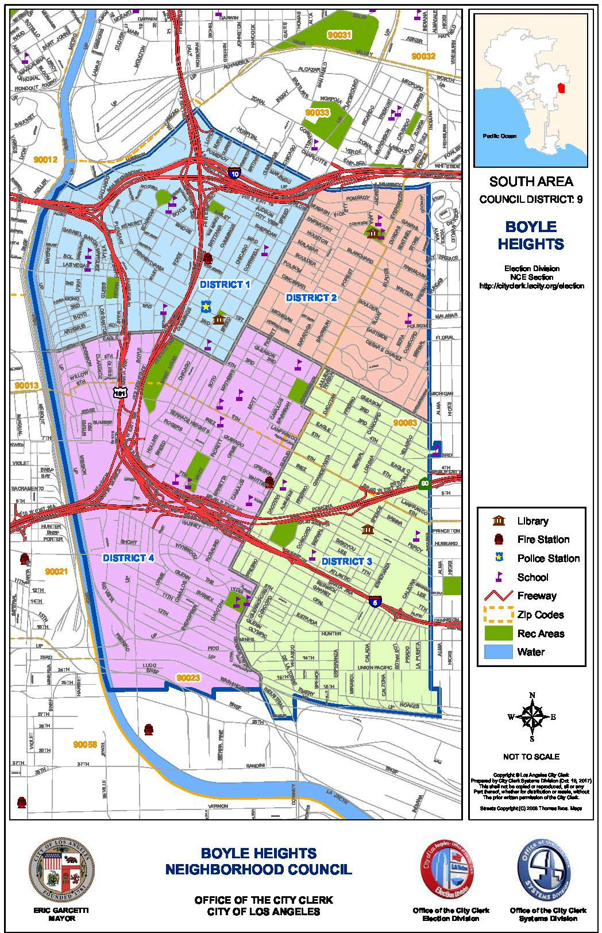

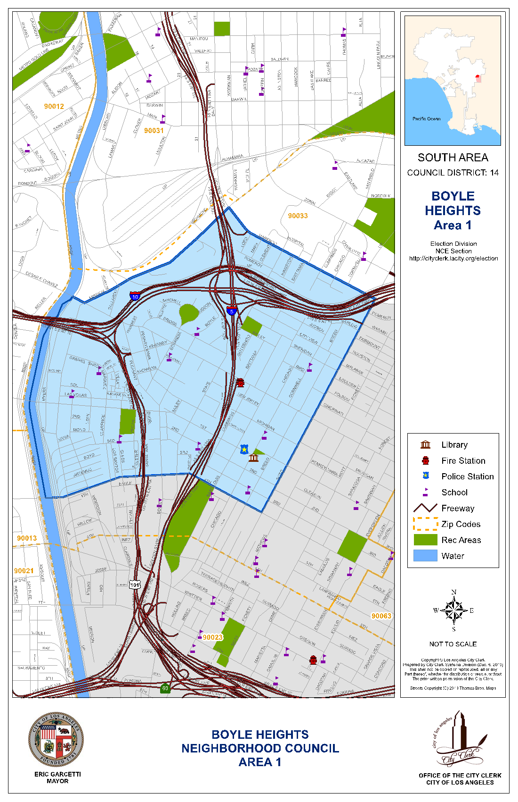
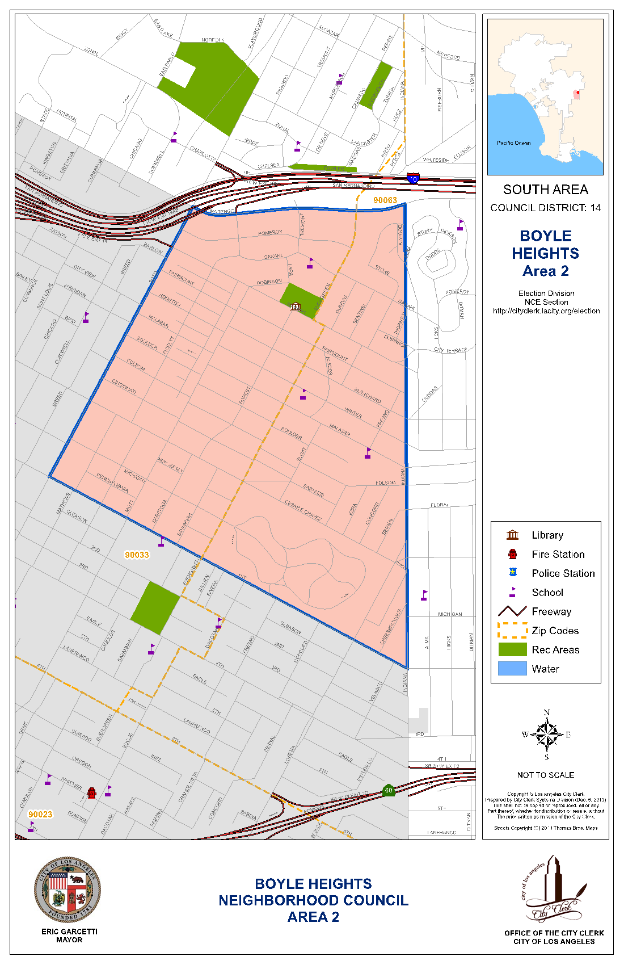
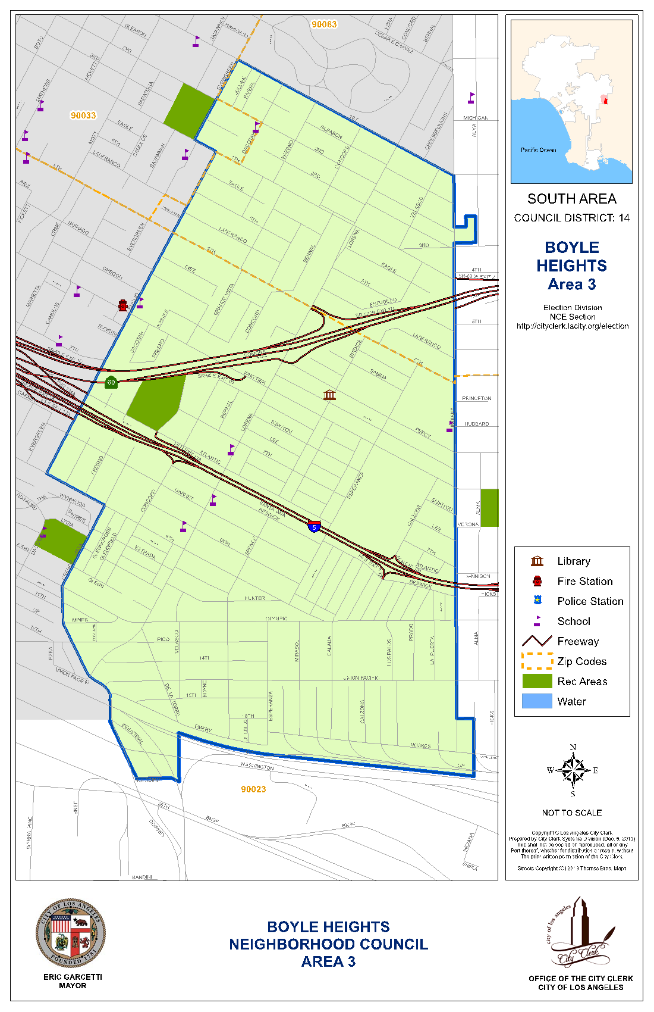
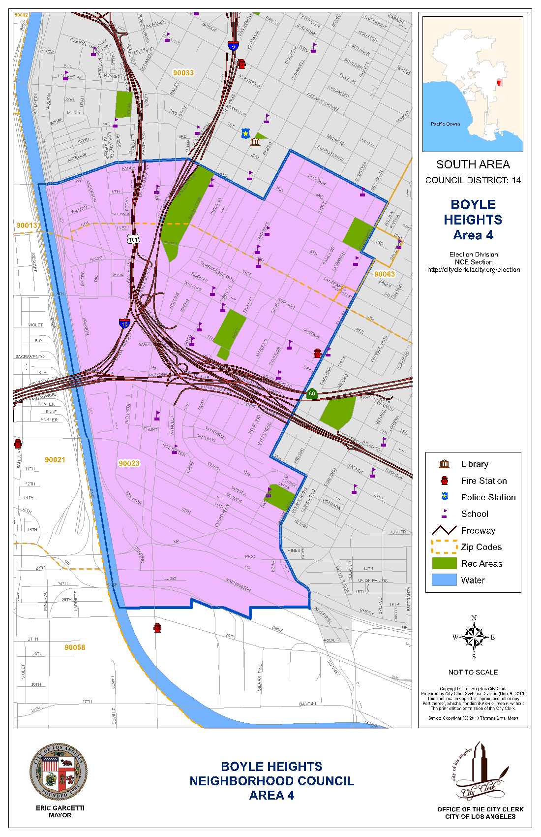
Attachment B – Governing Board Structure and Voting Boyle Heights Neighborhood Council – 19 Seats
Board Position | # of Seats  1 | Elected/Appointed?  Elected | Eligibility to Run for the Seat | Eligibility to Vote for the Seat
Area 1 Seat  Term: 2 Years |  |  | Stakeholders who live, work, own property in Area 1 and who are 18 years or older at the time of the election. | Stakeholders who live, work, own property in Area 1 and who are 16 years or older at the time of the election.
Area 2 Seat | 1 | Elected | Stakeholders who | Stakeholders who
Term: 2 Years |  |  | live, work, own | live, work, own
 |  |  | property in Area 2 and | property in Area 2 and
 |  |  | who are 18 years or | who are 16 years or
 |  |  | older at the time of the election. | older at the time of the election.
Area 3 Seat | 1 | Elected | Stakeholders who | Stakeholders who
Term: 2 Years |  |  | live, work, own | live, work, own
 |  |  | property in Area 3 and | property in Area 3 and
 |  |  | who are 18 years or | who are 16 years or
 |  |  | older at the time of the election. | older at the time of the election.
Area 4 Seat | 1 | Elected | Stakeholders who | Stakeholders who
Term: 2 Years |  |  | live, work, own | live, work, own
 |  |  | property in Area 4 and | property in Area 4 and
 |  |  | who are 18 years or | who are 16 years or
 |  |  | older at the time of the election. | older at the time of the election
Community Seat | 14 | Elected | Stakeholders who | Stakeholders who
Term: 2 Years |  |  | live, work, own | live, work, own
 |  |  | property in the BHNC | property in the BHNC
 |  |  | and who are 18 years | and who are 16 years
 |  |  | or older at the time of the election. | or older at the time of the election.
Community Interest Seat  Term: 2 Years | 1 | Elected | Stakeholders who are 18 years or older and declare a stake in the neighborhood as a community interest stakeholder, defined as a person who affirms a substantial and ongoing participation with a community organization that has continuously maintained a physical street address for not less than one year, and that performs ongoing and verifiable activities and operations that benefit the neighborhood, and is located within the NC’s boundaries. A for-profit entity shall not qualify as a Community Organization. | Stakeholders who are 16 years or older at the time of the election.
Youth Seat  Term: 1 Year | 1 | Elected/  Appointed by Board with Simple Majority Vote | Open to stakeholders between the ages of fourteen (14) and seventeen (17) on the day of the election or selection. See Admin. Code 22.814(c). If less than eighteen (18) years of age, the Youth Board Seat member shall be precluded from voting on financial matters, such as neighborhood council expenditures, financial reports, annual budgets, contracts, and recommendations to enter into contracts. | A person must be at least 14 years of age on the day that the Neighborhood Council election or selection for that Youth Board Seat occurs to be eligible to vote for a Youth Board Seat candidate.

