BYLAWS

OF THE

BEL AIR–BEVERLY CREST

NEIGHBORHOOD COUNCIL

Revised
11/16/2020
7/25/2022
10/27/2022

ARTICLE I - NAME 4
ARTICLE II - PURPOSE 4
ARTICLE III - BOUNDARIES 5
Section 1: Boundary Description 5
Section 2: Internal Boundaries 5
ARTICLE IV - STAKEHOLDER 5
ARTICLE V - GOVERNING BOARD 6
Section 1: Composition 6
Section 2: Quorum 11
Section 3: Official Actions 11
Section 4: Terms and Term Limits 11
Section 5: Duties and Powers 11
Section 6: Vacancies 12
Section 7: Absences 13
Section 8: Censure 14
Section 9: Removal 15
Section 10: Resignation 17
Section 11: Community Outreach 17
ARTICLE VI - OFFICERS 18
Section 1: Officers of the Board 18
Section 2: Duties and Powers 18
Section 3: Election of Officers 20
Section 4: Officer Terms 20
ARTICLE VII - COMMITTEES AND THEIR DUTIES 20
Section 1: Standing 20
Section 2: Ad Hoc 21
Section 3: Committee Creation and Authorization 21
ARTICLE VIII - MEETINGS 24
Section 1: Meeting Time and Place 24
Section 2: Agenda Setting 24
Section 3: Notifications/Postings 25
Section 4: Reconsideration 25
ARTICLE IX - FINANCES 26
ARTICLE X - ELECTIONS 26
Section 1: Administration of Election 26
Section 2: Governing Board Structure and Voting 27
Section 3: Minimum Voting Age 27
Section 4: Method of Verifying Stakeholder Status 27
Section 5: Restrictions on Candidates Running for Multiple Seats 27
Section 6: Other Election Related Language 27
ARTICLE XI - GRIEVANCE PROCESS 27
ARTICLE XII - PARLIAMENTARY AUTHORITY 28
ARTICLE XIII - AMENDMENTS 28
ARTICLE XIV - COMPLIANCE 28
Section 1: Code of Civility 28
Section 2: Training 29
Section 3: Self-Assessment 29
ATTACHMENT A – MAP OF NEIGHBORHOOD COUNCIL 30
ATTACHMENT B – GOVERNING BOARD AND VOTING 31
ATTACHMENT C – INTERNAL BOUNDARIES 32
ATTACHMENT D – INTERNAL BOUNDARY MAPS (Estimated) 35

ARTICLE I - NAME
The name of this neighborhood council of the City of Los Angeles (the “City”) shall be the Bel Air–Beverly Crest Neighborhood Council, which hereinafter may also be referred to as the “BABCNC” or “Council.”

ARTICLE II - PURPOSE
The Mission of the Council shall be:

(1) To provide an inclusive open forum for public discussion of issues concerning City governance, the needs of this neighborhood council, the delivery of City services to the stakeholders of this neighborhood council, and matters of a City-wide nature; and

(2) To advise the City concerning City governance, the needs of this neighborhood council, the delivery of City services to the Stakeholders of this neighborhood council, and matters of a City wide nature.

The Policy of this Council shall be upon the following tenets:

(1) Non-Discrimination. It shall be the policy of this Council to prohibit discrimination against any individual or group in our operations on the basis of race, religion, color, creed, national origin, ancestry, sex, sexual orientation, age, disability, marital status, income or political affiliation.

(2) Dignity. To respect the dignity and expression of viewpoints of all individuals, groups, and organizations involved in this Council.

(3) Inclusiveness and Non-Partisanship. To remain non-partisan and inclusive in our operations including, but not limited to, the election process for governing body and committee members.

(4) Early Notification System. To utilize the Early Notification System to inform our stakeholders of matters involving the City of Los Angeles (and our community) in a way that is tailored to provide opportunities for involvement in the decision-making process.

(5) Participation. To encourage all Stakeholders to participate in all activities of this Council.

(6) Transparency. To have fair, open and transparent procedures for the conduct of Council business.

ARTICLE III - BOUNDARIES

Section 1: Boundary Description
The area included in the BABCNC is defined by the following boundaries: (a) on the west by I-405 between Mulholland Drive and Sunset Boulevard; (b) on the north by Mulholland Drive between I-405 and Laurel Canyon Boulevard; (c) on the south by Sunset Boulevard between I-405 and Laurel Canyon Boulevard within the boundaries of the City of Los Angeles; and (d) on the east by Laurel Canyon Boulevard between Mulholland Drive and Sunset Boulevard. The area so defined excludes the incorporated limits of the Cities of Beverly Hills and West Hollywood.

Section 2: Internal Boundaries
Internal Boundaries of the BABCNC describe boundaries of five (5) Residential Districts identified under Article IV, Section 1(b). Given the meandering nature of many residential hillside streets that populate Council territory, internal boundaries of each Residential District cannot simply be described by metes and bounds of major roads, but can be more accurately described by a range of addresses along each residential street falling within each district. A detailed description of Council Internal Boundaries is provided in several tables appended to these Bylaws as Attachment “C.” A descriptive estimate of Internal Boundaries may be found by review of an Internal Boundaries Map appended herein as Attachment “D.”

ARTICLE IV - STAKEHOLDER
Neighborhood Council membership is open to all Stakeholders. A “Stakeholder” shall be defined as any individual who:
- Lives, works, or owns real property within the boundaries of the Neighborhood Council; or
- Is a Community Interest Stakeholder, defined as an individual who is a member of or participates in a Community Organization within the boundaries of the Neighborhood Council.
A “Community Organization” is an entity that has continuously maintained a physical street address within the boundaries of the neighborhood council for not less than one year, and that performs ongoing and verifiable activities and operations that confer some benefit on the community within the boundaries of the neighborhood council. A for-profit entity shall not qualify as a Community Organization. Examples of Community Organizations may include Chambers of Commerce, houses of worship or other faith-based organizations, educational institutions, or non-profit organizations.
[The definition of “Stakeholder” and its related terms are defined by City Ordinance and cannot be changed without City Council action. See Los Angeles Administrative Code Section 22.801.1]

ARTICLE V - GOVERNING BOARD
The Board of Directors (“the Board”) shall be the Governing Body of the Council within the meaning of that term as set forth in the Plan for a Citywide System of Neighborhood Councils (the “Plan”).

Section 1: Composition

*This board structure will take affect after the 2023 elections.

The Board shall consist of thirty-six (36) Members either: (i) elected directly by qualified Stakeholders at a City-administered election; (ii) appointed by the governing boards or membership of individual Residential Stakeholder Groups; or (iii) in the case of Non-Residential Group representatives, selected by the Board at a publicly noticed Meeting that culminates a process by which qualified Stakeholders are afforded an opportunity to run for such seats and be heard at the meeting at which such Member is seated to the Board as more fully described under Article X, Section 1.

Stakeholder Groups shall be categorized into the following categories for purposes of achieving diversity, and inclusivity of groups less inclined to seek representation on the Council.

(a) Appointed Residential Stakeholder Representation

Minimum Size. Appointed Residential Stakeholder Groups may be represented on the BABCNC by individual homeowner associations or individual residential groups comprising no fewer than one hundred (100) residential units. Those individual homeowner associations or individual residential groups comprising of fewer than 100 units may seek representation through representation with either:

- a neighboring homeowner association or residential group, with fewer than 100 units, so the combined units represented comprise of more than 100 units; or

- a neighboring homeowner association or residential group with more than 100 units with existing representation on the BABCNC.

- Apportionment of Seats.

The number of additional seats apportioned a Residential Stakeholder Group will be dependent upon the relative size of the number of residential units within the territory represented by such Residential Stakeholder Group.

Each Residential Stakeholder Group comprising no fewer than five-hundred (500) dwelling units will be apportioned one (1) additional seat for a total of two (2) seats.

Those Residential Stakeholder Groups comprising no fewer than one-thousand (1,000) dwelling units will be apportioned a second additional seat for a total of three (3) seats.

Those Residential Stakeholder Groups comprising no fewer than two thousand (2,000) dwelling units will be apportioned a third additional seat for a total of four (4) seats.

- Roster of Appointed Residential Stakeholder Groups and Apportioned Seats

- Bel-Air Association 4 seat(s)
- Bel-Air Crest Master Association 1
- Bel-Air Ridge HOA 1
- Benedict Canyon Association 4
- Doheny Sunset Plaza Neighborhood Association 1
- Casiano Estates HOA 1
- Laurel Canyon Association 4
- Holmby Hills HOA 1
- Residents of Beverly Glen 2
- Bel-Air Hills Association 2

- No Overlapping Boundaries.

To ensure the integrity of representation of each Appointed Residential Stakeholder Group, the territorial boundaries of each Appointed Residential Stakeholder Group shall be defined, and the territory of each Residential Stakeholder Group shall not overlap another.

- Alternate Representation.

Each Appointed Residential Stakeholder Group shall have the right to appoint or elect an alternate representative for each of its Board Member seats (“Alternate Board Member” or “Alternate”) in order that Appointed Residential Stakeholder Groups may be adequately represented at a Board Meeting in event one or more of its appointed Representative(s) cannot attend a Board Meeting. Each Residential Stakeholder Group desirous of appointing or electing an Alternate Board Member shall do so in accordance with its own procedures appointing regular Board Members, and may do so at any time by notifying the Secretary in writing with the names of the appointed Alternate Board Members. Each Alternate Board Member shall (i) comply with the same Ethics Requirement and funding training as provided under Article XIV - Compliance, Section 2: Training; and (ii) agree to the Code of Conduct Policy found at the Department of Neighborhood Empowerment’s website at http://empowerla.org/code-of-conduct/. Upon appointment or election of an Alternate, each Board Member of such appointing Residential Stakeholder Group shall jointly be responsible to carry out certain duties as more fully described in the Standing Rules.

(b) Elected Residential District Representatives.

Residential Stakeholders residing within geographic areas of Council territory not otherwise represented by Appointed Residential Stakeholder Group Representatives may be represented by Residential District Representatives elected at a public election conducted and administered by the City.

- Apportionment of Seats.

Each Residential District is apportioned one (1) seat with exception of the Bel-Air District and North of Sunset District. These Bylaws establish Residential District seats with the intent to engender active participation by Stakeholders from geographic areas within Council territory not otherwise represented on the Board, either due to a lack of interest by Stakeholders from such areas or a decision by residential groups representing such areas to no longer participate on the Board, leaving such Stakeholders without representation on the Board.

It is the intent of the Board to amend these Bylaws from time-to-time to increase the number of elected seats from Residential Districts if participation by Stakeholders from such districts increases over time.

- Roster of Elected Residential District Representation and Apportioned Seats.

- Bel-Air Glen District 1 seat(s)
- Franklin – Coldwater District 1
- North of Sunset District 3

- Alternate Representation.

Each Elected Residential District Representative shall have the right to nominate from within his or her Stakeholder constituency a qualified Stakeholder to act an Alternate when unable to attend any Board Meeting. Upon nomination, the Board shall approve appointment of such Alternate. Such Alternate may only assume duties on behalf of nominating Board Member upon completion and certification of requirements set forth under Article XIV - Compliance herein. Upon appointment of an Alternate, such nominating Board Member shall be responsible to carry out certain duties as more fully described in the Standing Rules.

(c) Selected Non-Residential Stakeholder Groups.

Selected Non-residential Stakeholder Groups shall consist of any private or faith-based group or institution, having a stake in the BABCNC, and any public or private group dedicated to the preservation of open space within the territorial boundaries of the Council.

- Apportionment of Seats.

Each Selected Non-Residential Stakeholder Group is apportioned one (1) seat.

- Roster of Selected Non-Residential Groups and Apportioned Seats

  - Custodians of Open Space 1 seat
      - Santa Monica Mountains Conservancy

  - Private Educational Institutions
    - Private Schools Grades K-6 1 seat
      - The John Thomas Dye School
      - Stephen S. Wise Elementary School

    - Private Schools Grades 7-12 1 seat
      - Harvard-Westlake School
      - Marymount High School

  - Faith-Based Institutions 1 seat
      - Stephen S. Wise Temple
      - Leo Baeck Temple
      - Chabad of Bel-Air

(3) Alternate Representation.

Each selected Non-Residential Stakeholder Group Representative shall have the right to nominate from within his or her Stakeholder constituency a qualified Stakeholder to act as an Alternate when the Representative is unable to attend a Board Meeting. Upon nomination, the Board shall approve appointment of such Alternate. Such Alternate may only assume duties on behalf of nominating Board Member upon completion and certification of requirements set forth under Article XIV - Compliance herein. Upon appointment of an Alternate, such nominating Board Member shall be responsible to carry out certain duties as more fully described in the Standing Rules.

(d) Elected Non-Residential Stakeholder Groups.

Elected Non-Residential Groups shall consist of any public group or institution having a stake in the BABCNC, and any group representing commercial or enterprise interests within the territorial boundaries of the Council.

- Apportionment of Seats.

Each Elected Non-Residential Stakeholder Group is apportioned one (1) seat.

- Roster of Elected Non-Residential Groups and Apportioned Seats.
- Public Educational Institutions 1 seat
    - Community Magnet Charter School
    - Roscomare Road Elementary School
    - Wonderland Avenue Elementary School

- Commercial or Office Enterprise Districts 1 seat
    - The Glen Centre
    - Moraga Enterprise Area
    - Roscomare Shopping Center
    - Canyon Store Area on Laurel Canyon
    - Glen Market Area on Beverly Glen

- Alternate Representation.

Each Elected Non-Residential Stakeholder Group Representative shall have the right to nominate from within his or her Stakeholder constituency a qualified Stakeholder to act as an Alternate when the Representative is unable to attend a Board Meeting. Upon nomination, the Board shall approve appointment of such Alternate. Such Alternate may only assume duties on behalf of nominating Board Member upon completion and certification of requirements set forth under Article XIV - Compliance herein. Upon appointment of an Alternate, such nominating Board Member shall be responsible to carry out certain duties as more fully described in the Standing Rules.

- Members-at-Large.

Four (4) Member At-Large seats shall be filled at a public election conducted and administered by the City.

Traditional Stakeholder Seats. Two (2) seats shall be open only to those individuals who
live, work, or own real property within the territorial boundaries of the Council.

Community Interest Stakeholder Seat. One (1) seat shall be open to only those individuals who declare a stake in the neighborhood as a Community Interest Stakeholder and are member of or participates in a Community Organization within the boundaries of the Council.

Youth Representative Seat. One (1) seat shall be open only to those Stakeholders who have attained at least fourteen (14) years of age but not more than seventeen (17) years of age at the time of the election to such seat. See Admin. Code § 22.814(c). If less than eighteen (18) years of age, the Youth Board Seat member shall be precluded from voting on financial matters, such as neighborhood council expenditures, financial reports, annual budgets, contracts, and recommendations to enter into contracts. This seat is exclusively reserved for a Stakeholder meeting such age requirements. Any vacancy created and filled by appointment may only be filled by a Stakeholder who meets such age requirements.

Alternate Representation. Each Member-at-Large Representative shall have the right to nominate from within his or her Stakeholder constituency a qualified Stakeholder to act as an Alternate when the Representative is unable to attend a Board Meeting. Upon nomination, the Board shall approve appointment of such Alternate. Such Alternate may only assume duties on behalf of nominating Board Member upon completion and certification of requirements set forth under Article XIV - Compliance herein. Upon appointment of an Alternate, such nominating Board Member shall be responsible to carry out certain duties as more fully described in the Standing Rules

- No Majority Stakeholder Group.

No single Stakeholder Group shall hold a majority of Board seats unless extenuating circumstances exist and are approved by the Department of Neighborhood Empowerment (the “Department” or “Empowerment”).

Section 2: Quorum
The presence at any Regular or Special Meeting of fifteen (15) Board Members, shall constitute a quorum for the purpose of transacting of business of the Council.

Section 3: Official Actions
Board Action. Notwithstanding a quorum obtained at a Meeting, and majority vote received as described in the following paragraph, Board Members, representing no fewer than fifty-percent (50%) of the quorum figure established in Section 2 of this Article must vote in the affirmative for the Board to take official action.

Majority Vote. All matters subject to a vote of the Board shall be determined by a majority vote of those Members voting (excludes abstentions), unless otherwise provided in these Bylaws. Voting may be by show of hands except that any Member may request a vote by any other manner adopted pursuant to these Bylaws, Department policies, and the Brown Act.

Open Meetings. All meetings of the Board are open to the public. All meeting procedures shall be in accordance with the State of California open meeting procedures that apply to Neighborhood Councils under the Brown Act, and Board of Neighborhood Commissioner policies, including the posting of notices and any other public communication in public places or through electronic media.

Special Meetings. A Special Meeting of the Board for a specific reason may be called at any time by either (a) any two (2) officers of the Board, or (b) a petition of a twenty-five percent (25%) of the Board Members, in accordance with the Brown Act.

Section 4: Terms and Term Limits
Appointed Stakeholder Groups. Board Members representing Appointed Stakeholder Groups are elected to terms and governed by term limits established in accordance with the bylaws, rules and practices of their respective Stakeholder Group, but such terms shall not exceed two (2) years.

Members-at-Large. Each Member-at-Large is elected to two (2) year term in accordance with the election schedule set forth by the City Clerk or the Department.

Section 5: Duties and Powers
Board Duties and Powers. The primary duties of the Board shall be to govern the Council and to carry out its objectives. No individual Member of the Board shall speak for the Board or otherwise publicly represent a Board position unless authorized to do so by official action of the Board. The Board may, by official action, delegate to any individual the authority to present before any public body a standing Council position previously adopted by the Board or a statement that the Council has had insufficient time to develop a position or recommendation on a matter before it. Such authority may be revoked at any time.

Member Duties and Responsibilities.

- Duty to Attend Meetings. Each Member of the BABCNC has a duty to attend Meetings on a regular basis, but it is also understood that a Member cannot make every Meeting due to uncontrollable circumstances.

- Duty to Represent Constituency. Each Member of the BABCNC shall be responsible for maintaining periodic contact with representatives of the respective Member’s constituent Stakeholder Group or its individual Stakeholders. Such communications shall involve reporting back to the constituent Stakeholder representative or individual Stakeholders about the work of the BABCNC and to solicit issues such representative or individual Stakeholders would like to see addressed by the BABCNC.

- Duty to Support Outreach Activities. As more expressly described in the Standing Rules each Board Member is expected to participate in at least one outreach activity of the Council each calendar year.

- Duty to Statement of Responsibilities. All incoming Board Members, and on an annual basis all Board Members, shall read, sign and abide by a Statement of Responsibilities, to be appended to the Standing Rules, and which shall include but not be limited to the duties set forth within this Section 5.

- Duties of Appointed Residential Stakeholder Representatives. At the beginning of each fiscal year, or immediately following approval by the Board of any new Board Member representing an Appointed Residential Stakeholder Group under these Bylaws, such Board Member shall provide within thirty (30) calendar days a writing on Group (i.e. homeowner association or homeowner group) letterhead, signed by an officer of Group verifying that such Board Member was duly appointed as Group’s BABCNC representative.

- Duties and Powers of Alternates Same as Board Members. For clarification under this Section, duly appointed Alternates for any Board Member shall have the same duties and powers of that Board Member with exception to attendance at Meetings. When present and sitting in for a Board Member not present at a Meeting, an Alternate shall be vested with all voting rights afforded the absent Board Member, and is counted for purposes of obtaining a quorum.

Section 6: Vacancies
Vacancies on the Board shall be filled using the following procedure:
Appointed Residential Stakeholder Group Members. The Stakeholder Group by which such Member was appointed shall immediately notify the Secretary of a vacancy of a Board seat upon knowledge of such vacancy. The Stakeholder Group shall move to fill the vacancy by appointing or electing another Member to the Board. If such vacancy is not filled within ninety (90) days of notice of such vacancy, such seat shall be converted to an elected At-Large position to be filled at the next election. Any Board Member may nominate, and the Board shall elect such new Board Member at the next scheduled publicly noticed meeting of the Board to fill such vacated seat and serve until certification of the next City-administered election.

Elected Members, Including At-Large Members. In event of resignation or creation of a vacant seat following a public election where no candidates run for such seats, any Board Member may nominate and the Board shall elect a new Board Member or Member-at-Large at the next scheduled publicly noticed meeting of the Board or as soon as practicable.

Selected Board Members. In event of resignation or abandonment by a Selected Member, that results in a vacant seat or in the creation of a vacant seat following a public selection where no candidates run for such seats, any Board Member may nominate, and the Board shall elect, a new Selected Board Member to fill such vacant seat at the next scheduled publicly noticed meeting of the Board, or a soon as practicable.

Section 7: Absences
In light of the duty of a Board Member described under Section 5(a), minimum attendance for each Board Member shall be no less than one (1) Meeting every three (3) consecutive Meetings. Attendance by an Alternate shall not constitute an absence, nor does an Excused Absence, as defined immediately below:

- Excused Absence. An “Excused Absence” by a Board Member shall include attendance at a Meeting by the Board-approved Alternate for such Board Member, or in the event of personal or family illness or medical emergency, the Board Member provides written notice to the Board’s Administrator or President in accordance with the Procedure summarized below and more fully described in the Standing Rules.

- Procedure If Unable to Attend Board Meeting.

  - Non-Excused Absence. When Board Member knows he/she/they will not be able to attend a publicly noticed Meeting of the Board, he/she/they shall inform the Administrator upon publication of the Agenda for the Meeting, and if applicable, inform the Alternate to afford opportunity for Alternate to arrange schedule to attend Meeting. If Alternate attends Meeting, Member’s absence is deemed an Excused Absence.

  - Excused Absence. Due to the emergency nature of a Board Member’s inability to attend a Meeting, a Board Member is requested to undertake a best effort to inform the Administrator, and the Alternate, if applicable, of inability to attend the scheduled Meeting as soon as practicable.

  - Standing Rules. More definitive procedures are described in the Standing Rules so such procedures may be amended from time-to-time as circumstances warrant.

Failure to meet this minimal attendance requirement may result in removal of the Member as provided under Section 9 below.

The Standing Rules shall provide a safeguard procedure whereby the President or Secretary directs the Council’s administrator to monitor on a monthly basis attendance by each Board Member, and upon two (2) consecutive absences authorizes the administrator to notify such Board Member by written communication that he or she has missed two (2) consecutive Board Meetings, and if deemed absent at the next Board Meeting, will be in breach of Duties as a Board Member and possibly subject to possible censure under Section 8, or removal under Section 9.

Section 8: Censure
The purpose of the censure process is to place a Board member on notice of misconduct and to provide the Board member with an opportunity to correct the misconduct. The Neighborhood Council (“Neighborhood Council”) may censure any Board member at a regular or special meeting open to the public following a good-faith determination by the Neighborhood Council Board that the member has engaged in conduct that is contrary to rules and regulations applicable to the Board or that impedes the orderly business of Board operations. Grounds for censure include, but are not limited to, persistent disruptive conduct at meetings, violations or abuses of the Board’s bylaws or rules, violations of the Code of Conduct, acting on behalf of the Board without authorization, and misuse or abuse of the censure or removal process by acting in bad faith.

The Board shall use the following procedure when censuring a Board member:

1. A motion to censure a Board member may be initiated by any three (3) Board members. Those Board members shall not constitute a majority of the quorum of any Neighborhood Council body, such as a committee. The motion shall be delivered to any officer of the Board or a specific officer or member of the Board as may be specified in the bylaws or standing rules of the Neighborhood Council. The motion shall be in writing and provide the specific facts and grounds for the proposed censure including the date(s) and specific conduct relied upon for the motion. The motion shall not be based upon conclusions, e.g., “for alleged violations of the Code of Conduct” but shall contain factual statements that describe conduct only and is not intended to embarrass or humiliate the board member.

2. The Board member, group of Board members or committee responsible for setting the final Board agenda shall include the motion on the agenda of the next regular or special Board meeting scheduled at least thirty (30) days following the delivery of the proposed censure motion.

3. The Board member subject to censure shall be given a minimum of thirty (30) days prior-written notice, which may include email sent to the last email address on file with the Neighborhood Council, of any meeting at which the motion to censure will be considered. The notice shall provide the specific facts and grounds for the proposed censure as specified in 1 above. The Board shall also provide a copy of the notice to the Department of Neighborhood Empowerment a minimum of thirty (30) days prior to the meeting at which the motion to censure will be considered.

4. The Board member subject to censure shall be given a reasonable opportunity to be heard at the meeting, either orally or in writing, prior to the Board’s vote on a motion of censure.

5. The Board shall decide by a majority vote of those present and voting whether or not the Board member should be censured. The Board member who is the subject of the censure motion shall not be counted as part of the majority present and voting and shall not be allowed to vote. For the purpose of censure motions, abstentions shall not be counted as votes.

6. In no event shall a motion to censure a board member be heard by the Neighborhood Council within sixty (60) days of the next scheduled Board election or selection.

Section 9: Removal
Any Board member may be removed by the Neighborhood Council (“Neighborhood Council”) for cause, following a good faith determination by the Board that the member has engaged in conduct that is contrary to rules and regulations applicable to the Board or that impedes the orderly business of Board operations. A Board member shall not be subject to removal under this Policy, unless the member has been censured at least once pursuant to the Board of Neighborhood Commissioners’ (“Commission”) Censure Policy. Grounds for removal include, but are not limited to, persistent disruptive conduct at meetings, violations or abuses of the Board’s bylaws or standing rules, violations of the Code of Conduct, acting on behalf of the Board without authorization, and misuse or abuse of the censure or removal processes by acting in bad faith.

The Board shall use the following procedure when removing a Board member:

1. A motion to remove a Board member may be initiated by any three (3) Board members. Those Board members shall not constitute a majority of the quorum of any Neighborhood Council body, such as a committee. The proposed motion shall be delivered to any officer of the Board or a specific officer or member of the Board as may be specified in the bylaws or standing rules of the Neighborhood Council. The motion shall be in writing and provide the specific facts and grounds for the proposed removal action including the date(s) and specific conduct relied upon for the motion. The motion shall not be based upon conclusions, e.g., “for alleged violations of the Code of Conduct” but shall contain factual statements that describes conduct only and is not intended to embarrass or humiliate the board member. The motion to remove shall also include a copy of the prior censure motion and the date it was passed.

2. The Board member, group of Board members or committee responsible for setting the final Board agenda shall list and briefly describe the motion on the agenda of the next regular or special Board meeting scheduled at least thirty (30) days following the delivery of the proposed removal motion.

3. The Board member subject to removal shall be given a minimum of thirty (30) days prior written notice, which may include email sent to the last email address on file with the Neighborhood Council, of any meeting at which a motion to remove will be heard. The notice shall provide the specific facts and grounds for the proposed removal as specified in 1 above. The Board shall also provide a copy of the notice to the Department of Neighborhood Empowerment a minimum of thirty (30) days prior to any meeting at which a motion to censure will be considered.

4. The Board member subject to removal shall be given reasonable time to be heard at the meeting, either orally or in writing, prior to the Board’s vote on a motion for removal.

5. The Board shall decide whether or not the Board member should be removed by an affirmative vote of two-thirds (2/3) of the currently sitting Board members. The Board member who is the subject of the removal motion shall not be allowed to vote and shall not be counted when determining the two-thirds (2/3) majority vote. For the purpose of the removal motion, abstentions shall not be counted as votes.

6. In no event shall a motion to remove a Board member be heard by the Neighborhood Council within sixty (60) days of the next election or selection.

7. The Commission may review a Neighborhood Council’s removal decision if requested to do so by the affected Board member. Once the request is made for the Commission to review the decision to remove, the Neighborhood Council voting to remove the board member may not fill the vacancy created by the removal until the Commission has made a decision on whether the removal was proper or the Commission declines to review the matter. The Commission’s decision whether to hear or decline to hear the removal review request shall be sent in writing to the requestor and the Neighborhood Council within 30 days after the request for review is delivered.

8. A request for the Commission to review a Neighborhood Council’s removal decision shall proceed as follows:

a. The request must in writing and must be delivered to the Executive Assistant of the Commission or, in the absence of an Executive Assistant, to the President of the Commission within thirty (30) days of the date of the action by the Neighborhood Council to remove the Board member.

b. The request must state the basis for the review. The request shall not cite or present any evidence not considered by the Neighborhood Council but must address only procedural deficiencies.

c. If the Commission determines the request for review raises sufficient questions regarding procedural deficiencies and agrees to hear the review, it will be placed on the agenda of a regular or special meeting of the Commission within sixty (60) days of receipt of the request for review.

d. At the review the Commission will determine if the facts as presented support the removal motion and if the procedures set out in this policy were correctly applied.

e. If the Commission determines that there were either factual or procedural deficiencies, the Commission may either reinstate the Board member or return the matter to the Neighborhood Council for further consideration.

f. If the Commission returns the matter for further consideration and the Neighborhood Council does not act within sixty (60) days of the Commission’s decision the Board member will be considered reinstated.

g. During the period of appeal the Board member shall not be counted as part of the Board for any quorum and shall not participate in any Board actions.

h. If the matter is returned to the Neighborhood Council for further consideration the Board member shall not be counted as part of the Board for any quorum and shall not participate in any Board actions until the Board takes action as requested by the Commission or until the expiration of the sixty (60) day time period.

9. This policy is not intended to restrict or eliminate a Neighborhood Council’s ability to remove or render ineligible to serve, Board members who fail to attend meetings, join committees, maintain their stakeholder status, or perform other duties as may be described in the Neighborhood Council’s bylaws and/or standing rules. Nor is it intended to limit a Neighborhood Councils ability to remove committee chairs or committee members according to the Neighborhood Council’s bylaws and/or standing rules.

Section 10: Resignation
A Board Member may resign at any time by giving written notice to the Secretary. Such notice shall provide an effective date of the resignation. In the case of a Board Member representing an Appointed Residential Stakeholder Group, the Appointed Residential Stakeholder Group shall notify the BABCNC Board of the appointment or election of a replacement in a writing delivered to the Secretary, pursuant to Section 6 of this Article.

Section 11: Community Outreach
The Council shall have a standing Outreach Committee, which will report its activities and recommendations to the Board monthly at the regular Council meeting. The Council shall maintain a website presence to disseminate information to Council Stakeholders and others interested in the Council.

ARTICLE VI - OFFICERS

Section 1: Officers of the Board
The Officers of the Board shall consist of President, Vice-President – Legislative Affairs, Vice President - Operations, Secretary, and Treasurer. In addition, the Council shall recognize the following offices in order to allow the experience and knowledge of past presidents to advise Officers of the Board.

Immediate Past President. The BABCNC shall have an ex-officio position of Immediate Past President that entitles the current outgoing President, if he/she so chooses, to hold a seat on the Executive Committee, which is advisory in nature only. The term of Immediate Past President shall extend until the next outgoing President chooses to assume the position of Immediate Past President.

Past President. If the outgoing Immediate Past President, continues to serve as an appointed or elected Member of the Board, he/she shall have the option to also serve on the Executive Committee, in the same advisory capacity as the Immediate Past President.

Section 2: Duties and Powers

(a ) President
The President shall have general supervision, direction, and control of all business and activities of the Board subject to Board approval. The President shall preside over all meetings of the Board and shall be an ex-officio member of all Committees.

(b ) Vice-President
The Office of Vice-President shall be bifurcated into offices equivalent in stature. Vice President – Legislative Affairs and Vice President – Operations. The principal role of each Office is to assist the President in carrying out the duties of President, as requested from time-to-time.

- Vice President – Legislative Affairs. This VP Office shall assist the President in monitoring all legislation of the City, and other governmental entities and agencies with jurisdiction over Council territory or that affects services delivered to Stakeholders. Such duties may include attendance at meetings and hearings of such legislative bodies or agencies and developing relationships with elected officials, executives, and staff.

- Vice President – Operations. This VP Office shall assist the President in the day-to-day operations of the BABCNC, managing the Administrator, responding to emails, assisting in the creation of the Meeting agenda, communicating with committee chairs as needed, as well as chairing Board Meetings in absence of President.

(c) Secretary
The duties of Secretary shall include the duties typically that of a corresponding secretary and recording secretary.

(1) Recording Secretary
Duties as recording secretary shall include, but not be limited to: (i) the recording and maintaining of all minutes of Board Meetings; (ii) preservation of all BABCNC records and documents; and (iii) maintain current Membership records.

(2)Corresponding Secretary
Duties as corresponding secretary shall include but not be limited to: (i) performing all general correspondence of the Board such as the posting of electronic notice of all Board meetings and Committee Meetings; (ii) ensuring that communication and information is disseminated evenly and in a timely manner to all Members and Stakeholders; and (iii) providing notice to all Members and Stakeholders of the time and location of all meetings of the Board at least 72 hours in advance.

(d) Treasurer
(1) The Treasurer:
i Shall maintain the BABCNC book of accounts, establish a system of financial accountability including the accounting of funds as allotted to the BABCNC, and ensure all accounting comply with applicable local, state, and federal laws in accordance with the requirements set forth by the City of Los Angeles Department of Neighborhood Empowerment (DONE), and report on the Council’s finances at Regular Meetings.

ii Ensure that the Council’s accounting books are open and available to all Stakeholders.

iiii Submit an account statement to DONE at least once a year or when requested otherwise.

iv Prepare an annual budget for expenditures to be approved by the Board and submitted to DONE for approval each year.

v Complete all training required by the City as such requirements may arise or mature.

(2) Assistant Treasurer
The position of Assistant Treasurer shall be established to assist the Treasurer in carrying out the duties as described under paragraph (d) above. It will be the option of the Board, with consultation of the Treasurer, to determine whether the position of Assistant Treasurer need be filled by a Member of the Board on a continuous basis. If the Board cannot fill the position, the Board may opt to retain a professional to assist the Treasurer, but such individual, not a Board Member, may not hold the position of Assistant Treasurer.

(e) Compensation
No Officer shall receive any compensation for any service rendered on behalf of the Council.

Section 3: Election of Officers
Each Officer shall be elected to a one (1) year term by a majority vote of the Board present by a show of hands at the first Board Meeting immediately following publication of the official canvass of votes of a City administered election and at the Board Meeting twelve (12) month following such Board election. Newly elected Officers shall assume office immediately following the Meeting at which the election of Officers is held.

Termination
Any Officer may be removed from office for cause and replaced by another Board Member by a majority vote of the Board voting, subject to the requirements set forth under Article V, Section 9, at duly noticed Meeting that affords the removed Officer due process. “For Cause” includes, but is not limited to, missing more than three (3) consecutive Board Meetings and more than three (3) Executive Committee meetings, the improper handling of Council funds or the improper application of accounting procedures.

Section 4: Officer Terms
Each Officer shall serve a term of one (1) year or until election of a successor. No individual may hold a particular office of the BABCNC for more than the later of:

- Five (5) consecutive years; or
- In event a successor to replace such individual is not available at expiration of the maximum term, such term may be extended but only until such time a successor is willing to assume such office.

Vacancy
Following a declaration by the Board that an office has been vacated, such vacancy may be filled by a majority vote of the Board Members voting, subject to the requirements set forth under Article V, Section 3, at a Board Meeting in accordance with the manner set forth herein and consistent with the Brown Act. Each Officer so elected shall hold office for the remainder of the original term or until election of a successor.

ARTICLE VII - COMMITTEES AND THEIR DUTIES

Section 1: Standing
The BABCNC shall have the following Standing Committees whose responsibilities are described hereunder whose description follows later under Section 4 of this Article: (i) Executive Committee; (ii) Planning and Land Use Committee; (iii) Bylaws, Rules and Elections Committee; (iv) Public Safety and Emergency Preparedness Committee; (v) Public Works and Telecommunications Committee; (vi) Outreach Committee; (vii) Traffic Committee; (viii) Budget and Finance Committee

Section 2: Ad Hoc
Each Ad Hoc Committee shall be established as a temporary committee to review and make recommendations on specific issues as directed by the Board. Ad Hoc Committee meetings shall be run by the Chair of the Committee appointed by the President. Minutes, reports and recommendations by such committees shall be delivered to the Secretary as they are issued. Ad Hoc committees will be comprised of less than a quorum of the governing body as a whole.

Section 3: Committee Creation and Authorization
(a) Establishment of Committees

A new Standing Committee or Ad Hoc Committee may be established at any Board Meeting by a motion supported by a majority of Board Members voting.

(b) Membership on Committees

- Standing Committees

  - Election. Upon establishment of a Standing Committee, and each year thereafter, the Board shall move to elect members to each Standing Committee, and membership shall only be conferred upon receiving a majority vote of Board Members present.

  - Term. The term of membership on each Standing Committee shall be for a period of at least one (1) year, but no more than two (2) years.

  - Re-election. During the second quarter of each calendar year, those members on Standing Committees whose term of such Standing Committee is more than one (1) year, but less than two (2) years, must be reelected by a majority vote of Board Members present to continue membership on such Standing Committee.

  - Candidacy. Candidacy for membership shall be open to all Stakeholders. Committee membership shall only be conferred upon receiving a majority vote of Board Members present.

  - Chair Position. The Chair of each Standing Committee shall be nominated by the President and elected by a majority of Board Members voting at a Meeting at which such committee is established.

  - Past Chair Position. The Chair of each Standing Committee may seek to create the position of Past Chair by requesting the Board to adopt a Standing Rule establishing the position of Past Chair on such Standing Committee.

- Ad Hoc Committees

  - Election. Upon establishment of an Ad Hoc Committee the Board shall move to elect members to an Ad Hoc Committee. Membership shall only be conferred upon receiving a majority vote of Board Members voting.

  - Term. The term of membership on an Ad Hoc Committee shall be for a period of no more than one (1) year.

  - Re-establishment. At the end of one (1) year’s term, existence of an Ad Hoc Committee shall be terminated unless a re-vote to continue the work of an Ad Hoc Committee is held and a majority vote of Board Members voting vote to continue the Ad Hoc Committee for a period of no more than one (1) year.

  - Re-election. Upon receiving a majority vote to continue the work of an Ad Hoc Committee, the Board shall move to elect or re-elect members to an Ad Hoc Committee. Membership shall only be conferred upon receiving a majority vote of Board Members voting.

  - Chair Position. Chair of an Ad Hoc Committee shall be nominated by the President and elected by a majority of Board Members voting at a Meeting at which such committee is established.
(c) Committee Meetings
Committee meetings shall be run by the Chair of the Committee. All Standing Committee meetings and meetings of Ad Hoc Committee whose membership constitutes more than a quorum of the Board or include non-Board members shall be open to the public. Notice of all committee meetings shall be posted seventy-two (72) hours in advance of a regularly scheduled meeting and twenty-four (24) hours in advance of a special meeting.

(d) Authorization and Purpose

- Executive Committee

The Executive Committee shall consider those issues pertaining to all Board financial matters and the distribution and allocation of Board funds. In addition, the Executive Committee shall advise on the administration, operations and management of the Council.

- Planning and Land Use Committee

The Planning and Land Use Committee shall consider those issues pertaining to land development.

- Bylaws, Rules and Elections Committee

The Bylaws, Rules and Elections Committee shall consider those issues pertaining to the continual study, interpretation, guidance and presentation of proposed changes to the Bylaws of the Board and Standing Rules. All proposed changes are to be presented to the full Board for its review and approval by a majority vote. In addition, the Committee shall be responsible for the coordination of all City election requirements for the election or selection of Board Members as well as the election of Board officers.

- Public Safety and Emergency Preparedness Committee

The Public Safety and Emergency Preparedness Committee shall consider those issues pertaining to public safety and disaster preparedness in coordination with police, fire, and emergency medical services.

- Public Works and Telecommunications Committee

The Public Works and Telecommunications Committee shall consider those issues pertaining to water, gas, electric and sewage lines; telecommunication infrastructure; and public rights-of-way and easements.

- Outreach Committee

The Outreach Committee shall consider those issues pertaining to outreach to our Stakeholder communities and shall include the responsibilities of disseminating and publishing information to the public as well as maintaining a presence in community relations through various electronic media, including but not limited to a website, email, as well as social media outlets such as Facebook, Twitter, and Nextdoor.

- Traffic Committee

The Traffic Committee shall consider those issues pertaining to traffic including the flow of traffic, safety, enforcement, congestion, parking, traffic signals and related street signs within the territorial boundaries of the Council.

- Budget and Finance Committee

The Budget and Finance Committee shall consider how the Council should best appropriate funds on deposit in its account and funds it receives annually from the City, and shall advise the Board of its responsibilities under Article IX herein. The Committee shall work closely with the Treasurer in carrying out such advisory duties. Duties of the Committee shall specifically include responsibility for soliciting as well as receiving, reviewing and submitting Neighborhood Purpose Grant (NPG) applications from not-for-profit community, charitable organizations, local governmental entities and agencies. Responsibilities shall include developing a well-defined procedure for review of NPG applications, including standards to be memorialized in the Standing Rules. Such standards shall include, but not be limited to: geographic benefit to Stakeholder Community; requiring applicant to submit adequate data to determine credibility of organization and proposed project; and weighing amount of funds requested against amount budgeted for NPGs for any given fiscal year. The Committee’s delegated responsibilities for NPGs shall remain until all forms are submitted to City and the project is complete.

ARTICLE VIII - MEETINGS
All meetings, as defined by the Ralph M. Brown Act (California Government Code Section 54950.5 et seq.), shall be noticed and conducted in accordance with the Act and all other applicable laws and governmental policy.

Section 1: Meeting Time and Place
(1) Regular Meetings

The Board shall meet at regular intervals, but not less frequently than once per calendar quarter. All meetings shall be held at a location, date and time set by the Board.

(2) Special Meetings

A Special Meeting of the Board may be called should exigent circumstances arise requiring the Board to meet at a date and time prior to its next Regular Meeting.

(3) Venue

The Board shall hold its regularly scheduled meetings at more than one (1) location, at least once a year, and that such alternative location be located in a different area of its territory not proximate to its regular Meeting venue, as an outreach effort to Stakeholders residing, working or owning property in areas of Council territory not proximate to the regular Meeting venue.

Section 2: Agenda Setting
The President shall have lead responsibility for setting the Board agenda, which shall be published in accordance with the Brown Act, and subject to Board input in accordance with the following procedure:

- No fewer than seven (7) days prior to a Regular Meeting the President shall email all Board Members for the purpose of soliciting input for items to be included on the agenda;

- Each Board Member shall have forty-eight (48) hours from the time the President distributes the email to respond to the request for agenda items;

- The President shall consult with a Vice President of the Board and one Committee Chair, which Committee Chair shall be identified in the Standing Rules, prior to finalizing the agenda for publication in accordance with the Brown Act;

- At the outset of each Regular Meeting, the President shall seek additional comment to the agenda from the Board, prior to amendment and final approval by the Board;

- The Board may only table items and may not add items not previously listed on the published agenda;

- The procedure described in the subsection shall not apply to Special Meetings of the Board. Agendas for Special Meetings shall be established at time they are called by the two (2) Officers calling for the Special Meeting or set forth in the petition signed by twenty-five percent (25%) of the Board Members as described under Section 3.

Section 3: Notifications/Postings
(1) Regular Meetings

Notice of all Regular Meetings of the Board and of its Committees shall be posted in accordance with The Ralph M. Brown Act, at no less than five (5) public places, which specific locations shall be specified (i) on the Department’s Public Notice Location Log on file with the City and (ii) listed at the website of the Council located at www.babcnc.org. Such notices shall also be distributed by email to the addresses of all Representative Members of the Board, Stakeholder Groups, and any individual Stakeholder of the Council providing such email address to the Secretary. The Secretary shall give notice of the time and location of all meetings of the Board at least seventy-two (72) hours in advance. The Board will also comply with the Commissioners Posting Policy.

(2) Special Meetings

The Secretary shall provide notice of any Special Meeting not later than twenty-four (24) hours in advance of a Special Meeting in the same manner as set forth under Paragraph 1 above.

Section 4: Reconsideration
The Board may reconsider and amend its action on items listed on the agenda if the reconsideration takes place immediately following the original action or at the next Regular Meeting. The Board, on either of these two occasions shall:

- Make a Motion for Reconsideration; and if approved

- Hear the matter and take an action.

If the Motion for Reconsideration of an action is to be scheduled at the next meeting following the original action, then the following two items shall be placed on the agenda for that meeting:

- A Motion for Reconsideration on the described matter; and

- A Proposed Action should the Motion for Reconsideration be Approved

A Motion for Reconsideration may only be made by a Board Member who has previously voted on the prevailing side of the original action. If a Motion for Reconsideration is not made on the date the action was taken, then a Board Member on the prevailing side of the action must submit a memorandum to the Secretary identifying the matter to be reconsidered and a brief description of the reason(s) for requesting reconsideration at the next Regular Meeting.

ARTICLE IX - FINANCES
A. The Board shall review its fiscal budget and make adjustments as needed to comply with City laws and City administrative rules and keep in compliance with Generally Accepted Accounting Principles and the City’s mandate for the use of standardized budget and minimum finding allocation requirements.

B. The Board shall adhere to all rules and regulations promulgated by appropriate City officials regarding the Council’s finances, where the term “appropriate City officials” means those officials and/or agencies of the City of Los Angeles who have authority over Councils.

C. All financial accounts and records shall be available for public inspection and posted on the Council website, if available.

D. Each month, the Treasurer shall provide to the Board detailed reports of the Council’s accounts.

E. At least once each quarter, the President and at least one (1) other individual other than the Treasurer, who is designated by the Board, shall examine the Council’s accounts and attest to their accuracy before submitting the documentation to the Department for further review.

ARTICLE X - ELECTIONS

Section 1: Administration of Election
Appointed Residential Stakeholder Groups. Appointment of Members representing each Appointed Residential Stakeholder Group of the Council is left to the particular election or selection process of each Appointed Residential Stakeholder Group.

Selected Non-Residential Stakeholder Groups. Members representing those Selected Non-Residential Stakeholder Groups identified under Article V, Section 1(c) shall be selected by the Board at a Regular Meeting whereby the Board will comply with City noticing requirements providing ample time for:
    - the Board to solicit candidates for such positions;

    - interested Stakeholder to respond by submitting a statement of candidacy for such position;

    - the Board to vet such candidates;

    - vetted candidates to campaign to their respective Stakeholder constituency; and

    - public notice of the Meeting at which such Selection will take place, with opportunity by the public to provide comment to the Board prior to selection of candidates to such positions.

Elected Residential District Representatives, Elected Non-Residential Stakeholder Group Representatives, and At-Large Members. Election of the foregoing Members of the Board, as further described under Article V, Sections 1, subparagraphs (b), (d) and (e), shall be at a public election conducted and administered by the City.

Section 2: Governing Board Structure and Voting
The Board is comprised of thirty-six (36) seats. Each Member or Stakeholder Group is assigned at least one (1) seat, with each seat having one (1) vote. The eligibility requirements for holding any specific Board seats, and which Stakeholders may vote for the Board seats are noted in Attachment B.

Section 3: Minimum Voting Age
Except with respect to a Youth Board Seat, a stakeholder must be at least 16 years of age on the day of the election or selection to be eligible to vote. [See Admin. Code §§ 22.814(a) and 22.814(c)]

Section 4: Method of Verifying Stakeholder Status
Voters will verify their Stakeholder status by providing acceptable documentation. Stakeholder status may also be established by means of declaring a stake (or interest) in the Council and providing documentation supporting that declaration.

Section 5: Restrictions on Candidates Running for Multiple Seats
A candidate shall declare their candidacy for no more than one (1) seat on the Council Board during a single election cycle.

Section 6: Other Election Related Language
Not applicable.

ARTICLE XI - GRIEVANCE PROCESS
The grievance process of the Council shall be compliant with the City’s newly adopted Grievance Policy. All grievances shall be submitted in writing to the Secretary before the next scheduled Agenda Setting Committee meeting for consideration and placement on the official agenda for the next scheduled Board Meeting. The process of grievance resolution shall be encompassed in the Standing Rules to be adopted by the Board, and consistent with the City’s new policy.

ARTICLE XII - PARLIAMENTARY AUTHORITY
(a) Rules
Except for rules adopted in the Bylaws, Robert’s Rules of Order, Revised Version, shall apply in the conduct of all Meetings of the Board.

(b) Parliamentarian
A Parliamentarian shall be appointed by the President and shall, as requested by the President or any Board officer, ensure that Robert’s Rules of Order Revised Version are followed during the course of all meetings.

ARTICLE XIII - AMENDMENTS
(a) Board Adoption
These Bylaws shall be amended by a two-thirds (2/3) majority vote of the Board Members present a Meeting on a proposed amendment distributed to Board Members for their consideration no less than seventy-two (72) hours before said Meeting.

(b) Not Effective Until Approved by the Department
Upon adoption, such amendment to these Bylaws shall be submitted to the Department for approval and shall not be effective and be valid until receiving such written approval from the Department.

ARTICLE XIV - COMPLIANCE
The Council, its representatives, and all Stakeholders shall comply with these Bylaws and with any additional Standing Rules or Procedures as may be adopted by the Board as well as all local, county, state and federal laws, including, without limitation, the Plan for Citywide System of Government (hereinafter referred to as “the Plan”), the City Code of Conduct, the City Governmental Ethics Ordinance (Los Angeles Municipal Code Section 49.5.1)(Code), the Brown Act (California Government Code Section 54950.5 et seq.), the Public Records Act, the American Disabilities Act, and all laws and governmental policies pertaining to Conflicts of Interest.

Section 1: Code of Civility
Incorporated under this section is the Code of Civility adopted by the Council at its Regular Meeting held on September 26, 2012.

The Bel Air-Beverly Crest Neighborhood Council adopts the Code collectively and individually as set forth in greater detail in the Standing Rules of the Council. The members of the Governing Board of the Council agree to abide by this Code lity to ensure that the Council’s business is conducted in a respectful, courteous, and effective manner, and in a way that will generate respect and credibility for our Council. Board members will abide by the Commission’s Neighborhood Council Board Member Code of Conduct Policy.

Code of Conduct

All incoming Board Members, and all Board Members as may be requested by the City from time to time, shall read, sign and abide by the Board of Neighborhood Commissioners Neighborhood Council Board Member Code of Conduct Policy. See http://empowerla.org/code-of-conduct.

Section 2: Training
The City requires that all Board members must take ethics and funding training prior to making motions and voting on funding related matters. There is no grace period to take ethics and funding training. Notwithstanding the foregoing, in the event of delinquency of a Board Member’s completion of his or her ethics training, which must be retaken every two (2) years, or completion of initial ethic training by a newly seated Board Member, the Board will permit such Member to vote on non-funding related matters, but only within a grace period of fifty-five (55) days, after which time such Board Member will lose all voting rights. All board members must take ethics and funding training prior to making motions and voting on funding related matters.

Section 3: Self-Assessment
Every year, the Council shall conduct a self-assessment pursuant to Article VI, Section 1 of the Plan.

ATTACHMENT A – MAP OF NEIGHBORHOOD COUNCIL

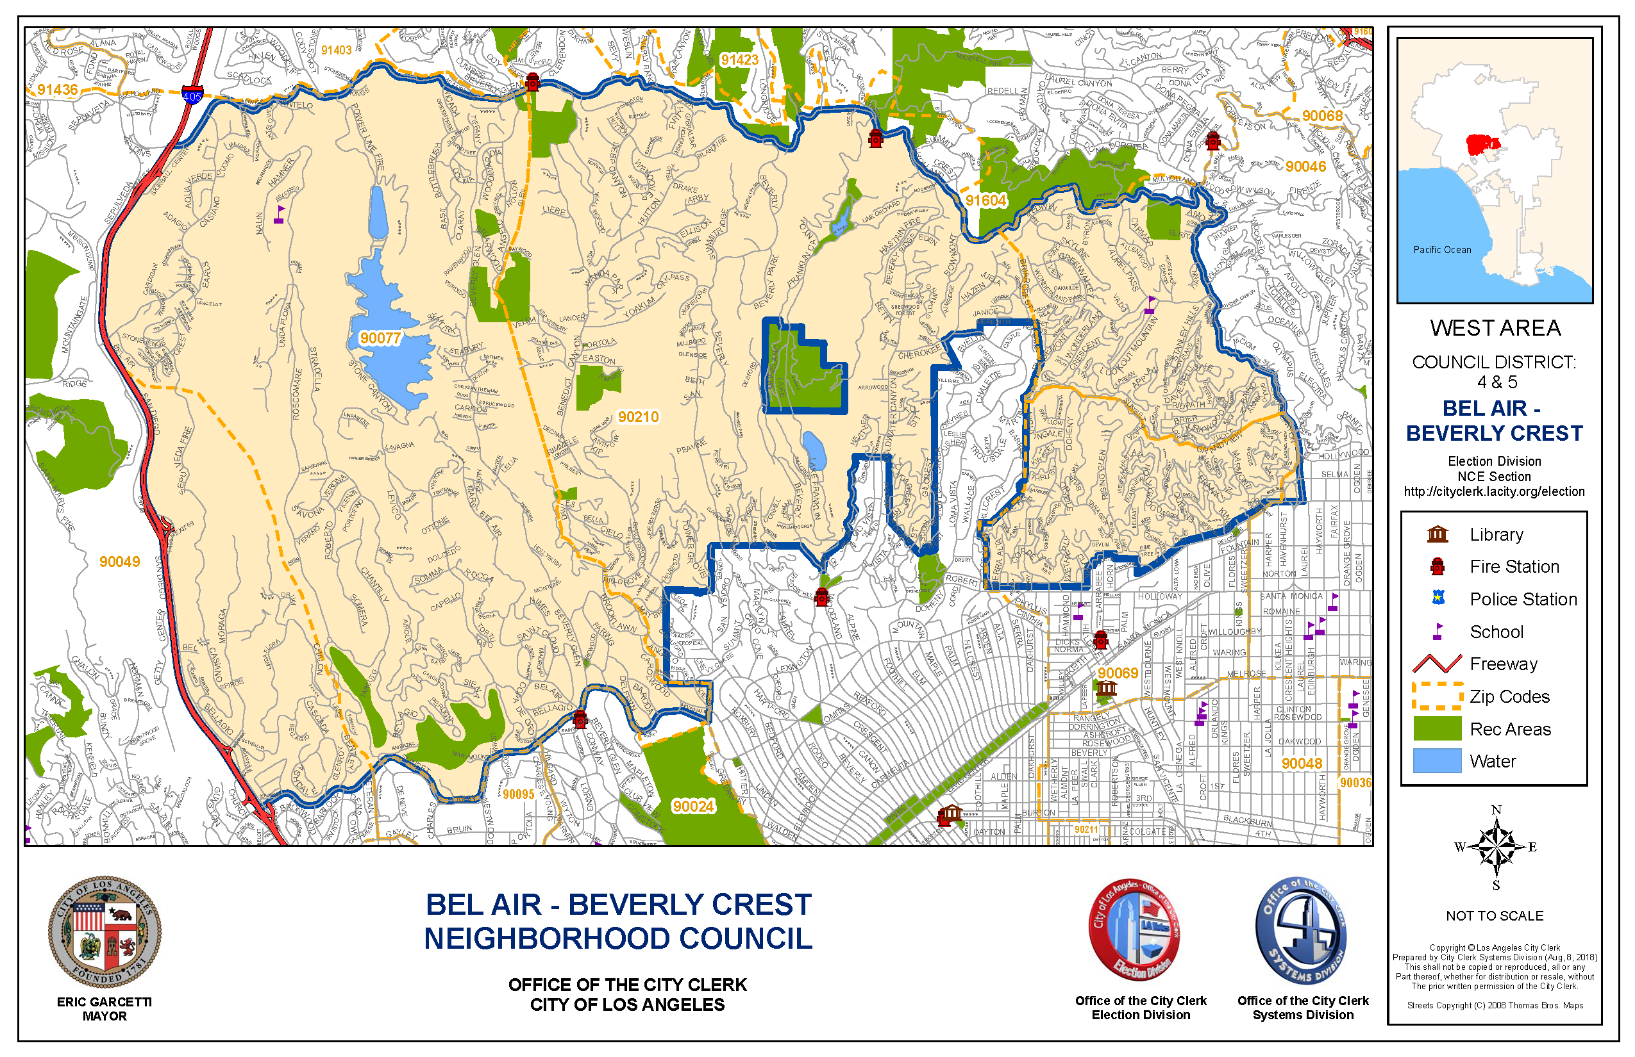

ATTACHMENT B – GOVERNING BOARD AND VOTING
Bel Air Beverly Crest Neighborhood Council -36 Board seats
BOARD POSITION | ELECTED  SELECTED OR  APPOINTED? | ELIGIBILITY TO RUN  FOR THE SEAT |  | ELIGIBILITY TO  VOTE  FOR THE SEAT
Residential Stakeholder Group Representative (21 seats)  Term: Not to Exceed 2 years | Appointed | Determined by bylaws or procedural practices of Residential Group. | Determined by bylaws or procedural practices of Residential Group.
Residential District Representative (5 seats)  - Bel-Air Glen District 1 Seat  - Franklin – Coldwater 1 Seat  - North of Sunset 3 Seats  Term: 2 years | Elected | Stakeholder at least 18 years of age at time of election who lives, or owns real property within internal boundaries of residential district. | Stakeholders at least 16 years of age at time of election who lives or owns real property within internal boundaries of residential district.
Non-Residential Group Representative – private & faith-based groups; custodians of open space.  (4 seats)  - Custodians of Open Space 1 Seat  - Private School K to 6th 1 Seat  - Private School 7th to 12th 1 Seat  - Faith-Based Institution 1 Seat  Term: 2 years | Selected | Stakeholder at least 18 years of age at time of Board Meeting appointing Non-Residential Group Representative with a substantial connection with private or faith-based group or institution, or custodian of open space whose seat is sought. | Board Membership
Non-Residential Group Representative – public groups & institutions; commercial enterprise. interests (2 seats)  - Public School 1 Seat  - Commercial/Office Enterprise 1 Seat  Term: 2 years | Elected | Stakeholder at least 18 years of age at time of election with a substantial connection with public group or institution or commercial interest whose seat is sought. | Stakeholders at least 16 years of age at time of election.
At-Large Traditional Stakeholder  (2 seats)  Term: 2 years | Elected | Stakeholder at least 18 years of age at time of election who lives, work or owns real property within territorial boundaries of the Council. | Stakeholder at least 16 years of age at time of election.
At-Large Community Interest Stakeholder  (1 seats)  Term: 2 years | Elected | Stakeholder at least 18 years of age at time of election. | Stakeholder at least 16 years of age at time of election.
At-Large Youth Representative (1 seat)  Term: 2 years | Elected | Stakeholder at least 14, not more than 17 years of age at time of election | Stakeholders at least 14 years of age at the time of election.

ATTACHMENT C – INTERNAL BOUNDARIES
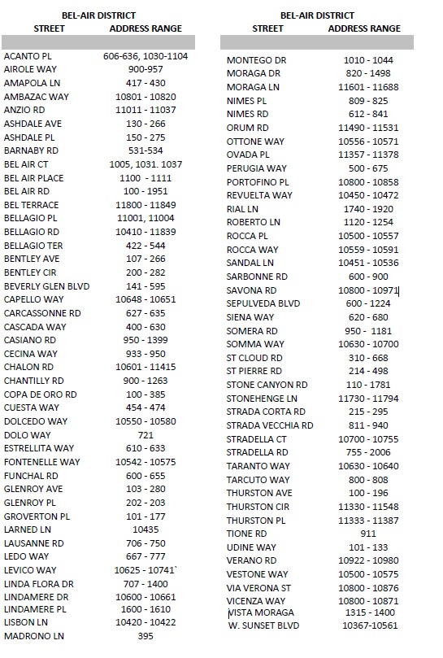

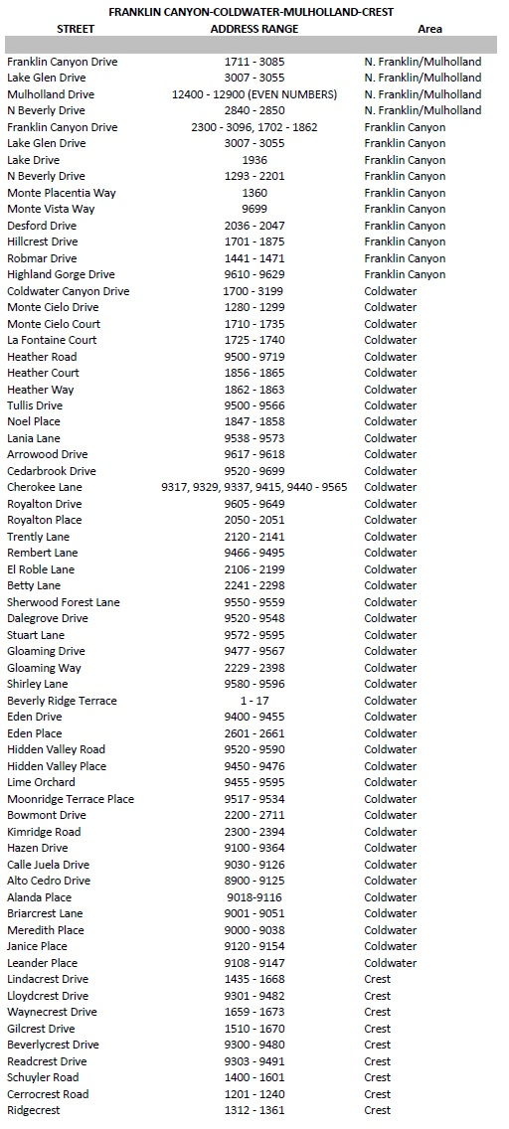
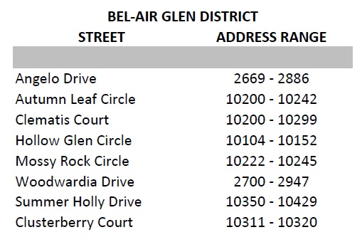

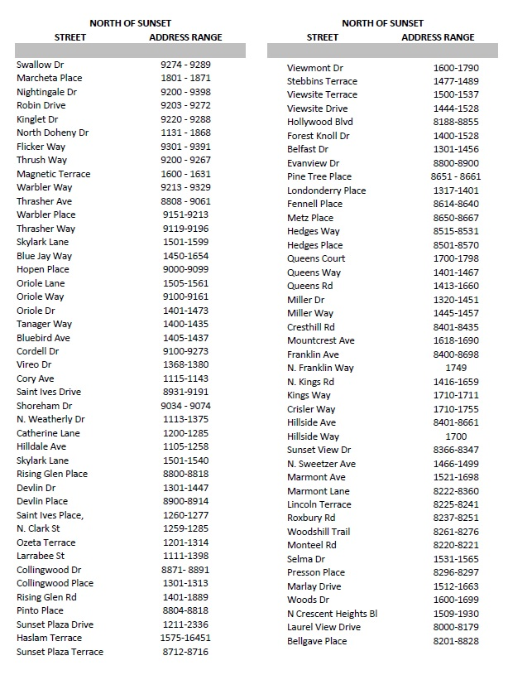

ATTACHMENT D – INTERNAL BOUNDARY MAPS (Estimated)
